ENME 690 Group G5

Project Report

Semiconductor Packaging Challenges in Future Automotive Electronics

December 16th, 2020

Arafat Hasnain

Yidi Shen

Thomas Jones

Raghav Agarwal

Matthew Siebenhuhner

# Table of Contents

I. Introduction 1

II. Vehicle Electrification 2

A. Design aspects for power electronics modules in Vehicle Electrification 2

B. Electrification Packaging in EV 2

i. Semiconductor Dies 3

ii. Die Attach Strategies 3

iii. Die Interconnects 5

iv. Substrates 6

v. Thermal Baseplate and Heatsink 6

vi. Encapsulation Materials 7

C. State of the Art Industry Module Designs 8

D. Future Trends within EV Module Design and Implementation 9

i. Transfer Molded Power Modules: 9

ii. Press-Pack Interconnects 10

iii. PCB integrated Power Modules : Arafat 11

iv. 3D Packaging and Advanced Materials : Arafat 11

III. Autonomous Driving 12

A. Introduction to Autonomous Driving 12

i. Definition with SAE Level Summary 12

ii. Current Autonomous Vehicle Industry 12

iii. Society Automotive Engineers (SAE) Autonomous Driving Levels 12

iv. SAE Autonomous Driving Level Timelines 13

B. Packaging Challenges 14

i. Requirements and Challenges 14

ii. ADAS Processors 15

iii. Sensors 16

iv. Radar 16

v. LiDAR 17

vi. Camera 19

vii. Software 20

IV. Vehicle Connectivity 20

A. Introduction 20

i. What is automotive connectivity? 20

ii. Hardware challenges and important problems in connectivity 22

B. Packaging Challenges 23

i. General Packaging Requirements 23

ii. Packaging Challenges and Related Technologies 24

iii. 5G communications 26

iv. Connectivity Processors 27

V. Conclusion 28

# Table of Figures

[Fig. 1: Global electric vehicle stock [2] 1](https://umd0-my.sharepoint.com/personal/hasnain_umd_edu/Documents/Group%20G5%20Final.docx#_Toc59004644)

[Fig. 2: Schematic diagram of a typical power electronics packaging [8] 3](https://umd0-my.sharepoint.com/personal/hasnain_umd_edu/Documents/Group%20G5%20Final.docx#_Toc59004645)

[Fig. 3:Comparison of Si, SiC, and GaN performances [9] 3](https://umd0-my.sharepoint.com/personal/hasnain_umd_edu/Documents/Group%20G5%20Final.docx#_Toc59004646)

[Fig. 4: Commercially available die attach materials for high temperature [10] 4](https://umd0-my.sharepoint.com/personal/hasnain_umd_edu/Documents/Group%20G5%20Final.docx#_Toc59004647)

[Fig. 5: Photographs and schematic representation of common interconnect strategies [12] 5](https://umd0-my.sharepoint.com/personal/hasnain_umd_edu/Documents/Group%20G5%20Final.docx#_Toc59004648)

[Fig. 6: Comparison between various substrate ceramic materials [14] 6](https://umd0-my.sharepoint.com/personal/hasnain_umd_edu/Documents/Group%20G5%20Final.docx#_Toc59004649)

[Fig. 7: Power Module mounted onto heat sink solution with TIM [9] 7](https://umd0-my.sharepoint.com/personal/hasnain_umd_edu/Documents/Group%20G5%20Final.docx#_Toc59004650)

[Fig. 8:MMC materials used for thermal baseplates [8] 7](https://umd0-my.sharepoint.com/personal/hasnain_umd_edu/Documents/Group%20G5%20Final.docx#_Toc59004651)

[Fig. 9: Schematic of a power module with TMC [18] 8](https://umd0-my.sharepoint.com/personal/hasnain_umd_edu/Documents/Group%20G5%20Final.docx#_Toc59004652)

[Fig. 10: Comparison of innovations in EV module design [9] 9](https://umd0-my.sharepoint.com/personal/hasnain_umd_edu/Documents/Group%20G5%20Final.docx#_Toc59004653)

[Fig. 11:Examples of PCB integration of power modules 11](https://umd0-my.sharepoint.com/personal/hasnain_umd_edu/Documents/Group%20G5%20Final.docx#_Toc59004654)

[Fig. 12: Timeline with milestones to achieve SAE level 5 [43] 13](https://umd0-my.sharepoint.com/personal/hasnain_umd_edu/Documents/Group%20G5%20Final.docx#_Toc59004655)

[Fig. 13:Automotive processor roadmap [49] 15](https://umd0-my.sharepoint.com/personal/hasnain_umd_edu/Documents/Group%20G5%20Final.docx#_Toc59004656)

[Fig. 14:Comparison of different automotive sensors [50] 16](https://umd0-my.sharepoint.com/personal/hasnain_umd_edu/Documents/Group%20G5%20Final.docx#_Toc59004657)

[Fig. 15:Cross-section drawing of an eWLB package for radar chips [51] 17](https://umd0-my.sharepoint.com/personal/hasnain_umd_edu/Documents/Group%20G5%20Final.docx#_Toc59004658)

[Fig. 16: Electronic parts of the LiDAR system [52] 17](https://umd0-my.sharepoint.com/personal/hasnain_umd_edu/Documents/Group%20G5%20Final.docx#_Toc59004659)

[Fig. 17:Example of mechanical spinning LidAR system [52] 18](https://umd0-my.sharepoint.com/personal/hasnain_umd_edu/Documents/Group%20G5%20Final.docx#_Toc59004660)

[Fig. 18:Wafer-level camera cross-section view [57] 19](https://umd0-my.sharepoint.com/personal/hasnain_umd_edu/Documents/Group%20G5%20Final.docx#_Toc59004661)

[Fig. 19:Examples of connected cars [47] 21](https://umd0-my.sharepoint.com/personal/hasnain_umd_edu/Documents/Group%20G5%20Final.docx#_Toc59004662)

[Fig. 20: IVI System Architecture [62] 23](https://umd0-my.sharepoint.com/personal/hasnain_umd_edu/Documents/Group%20G5%20Final.docx#_Toc59004663)

[Fig. 21: Different application of frequency band [64] 24](https://umd0-my.sharepoint.com/personal/hasnain_umd_edu/Documents/Group%20G5%20Final.docx#_Toc59004664)

[Fig. 22:Typical IC packages roadmap for automotive dashboard applications [63] 24](https://umd0-my.sharepoint.com/personal/hasnain_umd_edu/Documents/Group%20G5%20Final.docx#_Toc59004665)

[Fig. 23:Flip chip technology eliminates wire bonds and enhances chip and assembly yields[65] 25](https://umd0-my.sharepoint.com/personal/hasnain_umd_edu/Documents/Group%20G5%20Final.docx#_Toc59004666)

[Fig. 24:Evolution of Fan out MCM-Sip [63] 26](https://umd0-my.sharepoint.com/personal/hasnain_umd_edu/Documents/Group%20G5%20Final.docx#_Toc59004667)

[Fig. 25:Example of 5G Use Case Supporting C2X10 [66] 26](https://umd0-my.sharepoint.com/personal/hasnain_umd_edu/Documents/Group%20G5%20Final.docx#_Toc59004668)

[Fig. 26:Disruptive SiP Architectures expected in 5G mmWave [66] 27](https://umd0-my.sharepoint.com/personal/hasnain_umd_edu/Documents/Group%20G5%20Final.docx#_Toc59004669)

# Introduction

Interest in renewable energy is at an all-time high in order to mitigate effects of global warming. A renewable energy technology that is very popular these days is electric vehicles (EV) comprising of battery electric vehicles (BEV) and plug-in hybrid electric vehicles (PHEV). There are important advantages of EVs with decreased global greenhouse gas emissions and enhanced vehicular performance [1] .

From IEA [2], the total global sale of electric cars in 2019 is 7.2 million accounting for 2.6% of total car sales shown in Fig. 1. A projection using existing government policies show that global electric vehicle stock is expected to increase to 140 million vehicles and using the sustainable projection scenario, it is expected to rise up to 245 million vehicles stock by 2030. The DOE has also set a US DRIVE goal by 2025 of “an electric traction drive system at a cost of $6/kW for a 100 kW peak system” with an additional goal of power density target of 33 kW/L for a 100 kW peak system [3]. The key challenge of EVs is to ensure cost-competitive products with estimations showing that EV will match costs internal combustion engine vehicles in the mid-to-late 2020s due to plummeting lithium-ion battery costs [4],[5] .

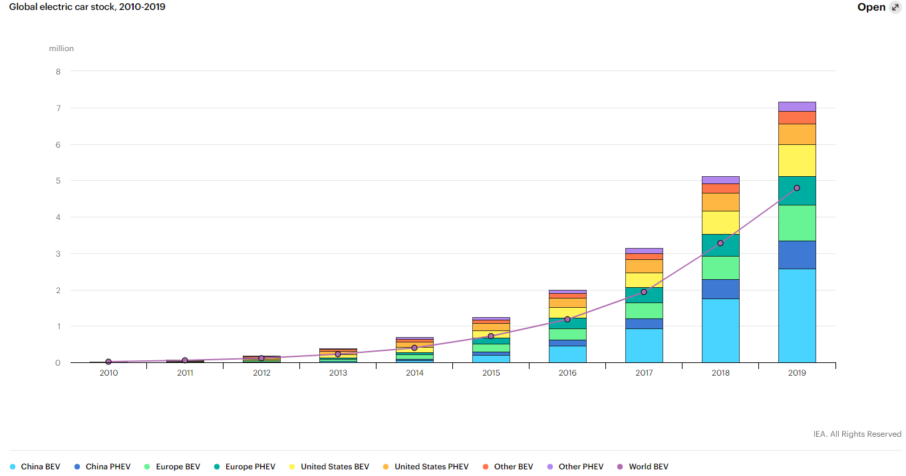

**7.2 million**

Fig. 1: Global electric vehicle stock [2]

The progression of modern and future automotive electronics is guided by three different categories: Electrification, Autonomous driving, and Connectivity [6]. A common trait between these categories is the importance of semiconductor packaging in EV. To further the growth of EV, efficient semiconductor packaging is essential as there are many challenges due to the operating requirements of EV. This paper summarizes the key concepts of each major EV development category to provide a clear picture of the future concerns of packaging in EV. Section II discusses the important of electrification with the focus on power electronics. Section III considers the packaging of electronics in autonomous or self-driving concerns that will revolutionize vehicle transportation and Section IV explores the concept of connectivity in the context of automotive electronics. Finally, conclusions summarizing the main discussion points are provided in Section V.

# Vehicle Electrification

## Design aspects for power electronics modules in Vehicle Electrification

Automotive electrification concerns itself with the elimination of the standard internal combustion engine (ICE) found in most vehicles on the road today. In place of the ICE, battery-driven electric motors are used to provide propulsion for the vehicle. In order to drive the motor, the battery direct current (DC) must be “inverted” or modulated into an alternating current (AC) waveform to drive the motor. This switching is accomplished by power semiconductor dies (such as Silicon and Silicon Carbide). Merely switching DC to AC is half the battle, as these dies must be carefully assembled into circuits, electrically connected, kept within a safe operating temperature range, be mechanically reliable, and electrically efficient for the lifetime of the vehicle.

To achieve more efficient electric vehicles, the role of power electronics is very important. The power electronics for electric vehicle market size was valued at $2.59 billion in 2018, and is projected to reach $30.01 billion by 2026 [7]. Proper packaging of a power electronics module specifically the semiconductor devices is always important, but it is more so in the case of electric vehicles because of various strict design considerations. The most significant design challenge is to ensure low cost for high production volume. This is a challenge that can be solved by further iterations of optimized design that meets some of the following requirements.

A major roadblock for electric vehicles is not having enough state of charge of the battery. This is related to the concept of ‘range anxiety’ where the drivers are worried that the car battery will run out in the middle of driving. One workaround solution is to have a bigger battery pack that does not increase the car size and weight. As a result, the module power electronics packaging needs to be small to have more space for the battery pack. Effectively, the packaged module has to have high power and energy density. In addition, the packaging needs to ensure that all fundamental major electrical requirements such as current, voltage, power ratings are met. There are other key criteria such as ensuring high efficiency with low power loss and also limited electromagnetic interference (EMI).

An integral method of ensuring high efficiency is by having a proper thermal management for the packaging. Attention to CTE mismatch between different materials and understanding of the temperature distribution are needed for good thermal management to operate in a wide range of operating temperature. The power module also needs to be robust against mechanical shock and vibration since the package will be on a moving vehicle. Similarly, there needs to be good reliability in terms of joint failure, temperature, and power cycling performance. As a result, there are various design aspects for the electrification packaging that need to be optimized for further growth of electric vehicles in the overall car market share.

## Electrification Packaging in EV

So far there has been a discussion on the different design challenges of the semiconductor packaging. This section will cover some of the basic elements of a power module for electric vehicles with a typical schematic shown in Fig. 2 [8].

### Semiconductor Dies

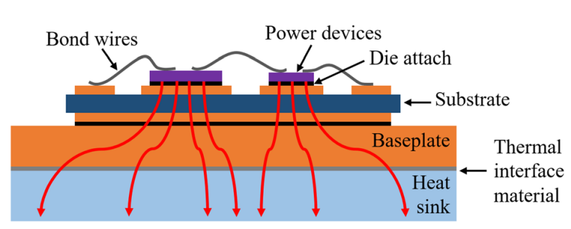

Fig. 2: Schematic diagram of a typical power electronics packaging [8]

The main part of the power module is the semiconductor device or the die. Most commonly used devices for electric vehicles that are available in industry are the silicon (Si) insulated gate bipolar transistors (IGBT). However, there is increasing interest in wide band-gap (WBG) devices such as Silicon Carbide (SiC) and gallium nitride (GaN) due to a number of advantages. A comparison of the key characteristics of these devices are shown in Fig. 3 [9]. Due to higher thermal conductivity and maximum operating temperature, SiC and GaN devices have easier associated thermal management. There are other electrical advantages mainly lower switching losses which permit the use of the converter in higher frequencies which lead to lower overall module volume. The state-of-the-art commercial products for SiC are in the high voltage applications for above 1200 V and the highest available commercial GaN devices are in the 650 V range. Since SiC and GaN have definite performance advantages over Si based devices, it is expected that in the near and most definitely long term, the electrification power modules will consist of WBG dies.

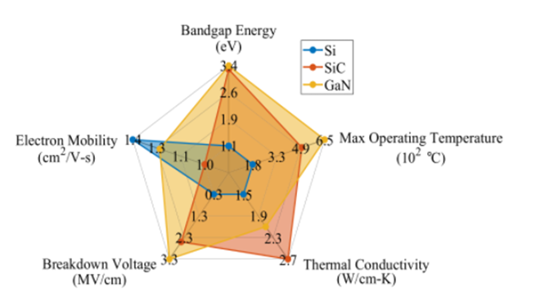

Fig. 3:Comparison of Si, SiC, and GaN performances [9]

### Die Attach Strategies

Die attach acts as a mechanical, electrical, and thermal interface between the power semiconductor die and the carrier substrate to which it is attached. From [10], the critical features of die attach material to consider are the liquidus and solidus temperatures, the electrical conductivity, thermal conductivity, and mechanical stability. For automotive power modules, the industry is trending towards smaller and more dense designs. In order to accomplish this, modules need to be able to operate at higher temperatures. For die attach, this new requirement poses a challenge as many of the solders typically used in the electronics manufacturing industry – such as SAC305 – are no longer viable as the operating temperatures approach or exceed the melting temperatures of the solder. For instance SiC have the potential of being operated up to 300C which is well above the melting point for most typical solders [11]. Fig. 4 contains a list of commercial die attach solutions for high temperature applications.

Leaded solders have long been used for high temperature power applications due to their cost and well understood metallurgy and reliability. They offer a highly ductile joint, with very good electrical and thermal conductivities with low surface tension [10]. However, these materials are seeing reduced use in newer products as lead is a known toxin and is highly dangerous to human life [8].

As a replacement to leaded solders, many novel solutions have been developed and introduced into the market. Gold-based solders are well accepted, they possess a high melting temperature and good thermal conductivity. The most common, Au-Sn, however, is very brittle and stiff due to intermetallic formations which lead to solder joint cracking and delamination[10]. Gold-based alloys are also very expensive and rather cost-prohibitive to anything but niche applications. Other alloys have been investigated, such as zinc and bismuth, which have shown good potential – not least of which is reduced cost over gold-alloys. All lead-free solders form intermetallic compounds within the bond that reduce the bond properties and can lead to failures [8].

Another die attach solution gaining momentum is a silver-based nano-particle system for pressure sintering [10]. Silver has a melting point of 961⁰C which makes it impractical for use as a soldering material. However, by reducing silver to micro or nano-scale particles, they can be joined together well below the melting point [8]. Commonly, sintering occurs along with applied pressure to provide a good bond between the die and substrate. Sintered silver die attach has been shown to be very stable in thermal shock and power cycling testing with little to no bond degradation compared to standard leaded solder [11].

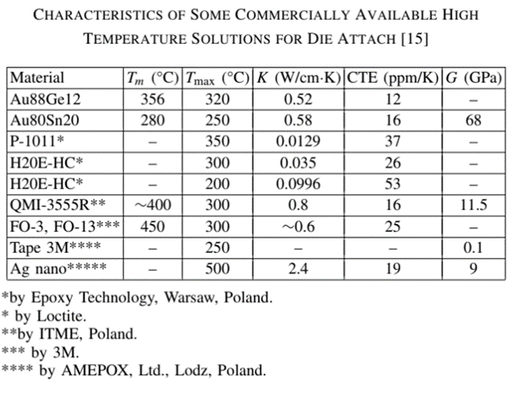

Fig. 4: Commercially available die attach materials for high temperature [10]

### Die Interconnects

Power dies attached to a substrate need to be electrically interconnected to the remainder of the circuit in order to be functional. These interconnections serve as both the power-transport mechanism for the module as well as control and signal interfaces to manipulate the device gate and other sensing considerations within a module. A summary of common interconnect technologies is presented in Fig. 5.

The most common of these interconnect strategies is aluminum wire bonding. Aluminum wires are wedge bonded into the die topside pads and to the substrate or other dies to make electrical connection. This technology is very mature and such the wire bonding systems and material are very inexpensive, however, with the increasing trend towards higher power, the relatively low ampacity of the aluminum wires are becoming a major bottle neck [12]. Aluminum wire has poor power cycling performance due to the CTE mismatch between the silicon die and wire [13].

In order to increase the current carrying capacity of the existing aluminum technology, aluminum ribbons are becoming more common. Like aluminum wire bonds, aluminum ribbon is very comparable with the aluminum surface metallization of most common dies. However, due to the increased cross-sectional area, ribbons possess a higher current carrying capacity and smaller inductive losses than wires [12]. Despite the benefits noted here, however, Aluminum ribbons do not show much improved power cycling performance [13].

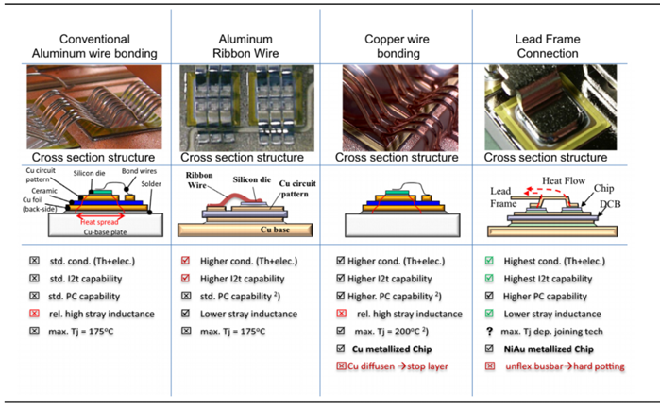

Fig. 5: Photographs and schematic representation of common interconnect strategies [12]

Copper wire bonding has also gained popularity due to its native higher ampacity (current carrying capacity) and higher temperature stability. Copper wires realize much the same bonding geometries as Aluminum wires, however, so the inductive losses are similar in scale [12]. In order to realize robust copper wire bonds on die top, a very thick layer of copper is needed on die topside to mechanically handle the bonding process [13]. Despite this added complexity, Copper wire bonds are far more stable in power cycling due to closer matched CTE between the copper and silicon. A potential downside to Copper wire bonding, however, is the requirement of copper-plating on the top of the die. Copper atoms could diffuse into the silicon and negatively impact the doping of the silicon junction. This contamination of the junction would render the device useless.

Another common method of die interconnection is connection by copper lead frame. These lead frames are made from stamped copper and can be sintered or soldered onto the device topside. This, however, requires that the die topside have a compatible metallization on the die top which is commonly Ni-Au plating. Lead frames possess the lowest stay inductance of all discussed interconnect methods. Furthermore, due to the generally large contact area with the active part of the die (die junction), lead frames function as a heat spreader both to more uniformly distribute heat across the whole of the junction during operation but also to draw heat away from the die when switched off. Due to the relative stiffness of the lead frame, however, it is common to hard-pot or resin-encapsulate such devices to mitigate shear stresses during life cycle operation [12].

### Substrates

Substrates for power electronics modules act as both a thermal and electrical pathway for the high-power dies populated on top. The most common form of power electronic substrate uses a ceramic tile clad with copper or aluminum on either side. The most common ceramic types are present in Fig. 6 [14]. The ceramic acts as an electrically insulating barrier and a thermal interface between the top and bottom layers of metal. The top layer of metal is patterned with circuit traces for die bonding and interconnects and the bottom is typically left un-patterned to act as a thermal interface and heat spreader for the next level of assembly [8].

There are two primary methods of bonding the substrate metals to the ceramic tile. The first of these technologies is direct bond copper or DBC. This technology relies on copper oxide interdiffusion with the ceramic material to form a strong bond when processed at a high temperature of 1065°C. The other method is active metal brazed or AMB technology wherein the metals are bonded to the ceramic using a braising alloy which is commonly silver based [15].

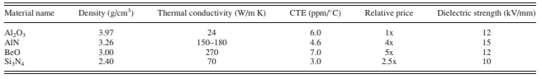

Fig. 6: Comparison between various substrate ceramic materials [14]

### Thermal Baseplate and Heatsink

Substrates, once populated with dies, are typically soldered to a heat spreader typically made from aluminum or copper. Typical power module base plates are not made from pure metals but rather a metal matrix composite (MMC) to reduce the metal CTE and reduce stresses between the substrate and base plate. The MMC is joined to a cold-plate or other cooling solution with a thermal interface material [8] as shown in Fig. 7.

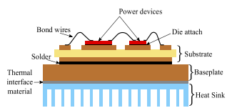

Fig. 7: Power Module mounted onto heat sink solution with TIM [9]

As operating temperatures and power densities of modules increase, the practice of mounting a baseplate on heatsink with thermal grease is being rejected in favor of a shorter thermal path [8]. Many power modules are being developed with an integrated heatsink made of MMC materials[8], [9]. Fig. 8 shows many common heatsink and thermal baseplate materials. This allows for more compact modules with a lower thermal resistance from the die junctions to the coolant.

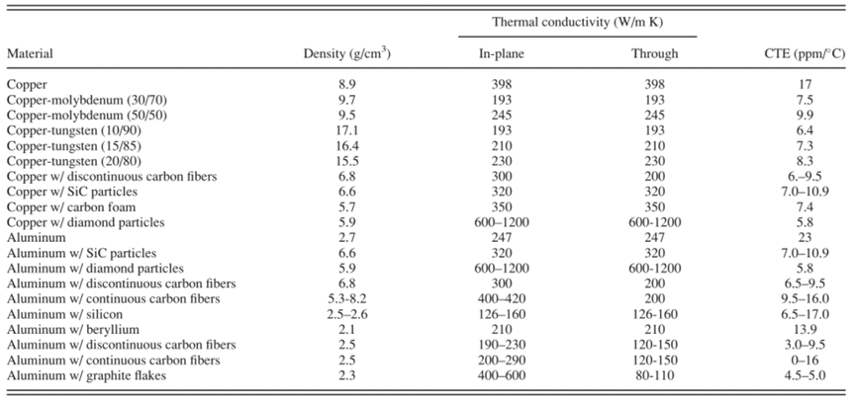

Fig. 8:MMC materials used for thermal baseplates [8]

### Encapsulation Materials

Encapsulation materials are generally required to protect the devices from external factors such as moisture. They can also improve the voltage ratings of the packages, in high voltages modules [16] for SiC packages. There are two layers of encapsulation materials [9]. A thin passivation layer is placed on the top surface of dies for insulation to limit leakage current. This layer is typically based on polyamide materials with high breakdown strength. An additional layer can be placed on top of the existing passivation layer for more insulation and protection under harsh conditions. Materials for this additional layer can be of silicone gels and silicone elastomer [17]. The limitation of these materials is that they have low thermal conductivity. To solve this issue, alternatives in inorganic materials such as ceramics are being considered [18]. Due to the higher thermal conductivity of ceramics, the transient thermal resistance of the module is improved. Shown in Fig. 9, an additional copper heat spreader called as thermal mass circuit (TMC) is applied to the top of the ceramic encapsulation providing vertical heat flow and removes the thermal energy from the encapsulation. This procedure enhances the cooling efficiency of the power module package.

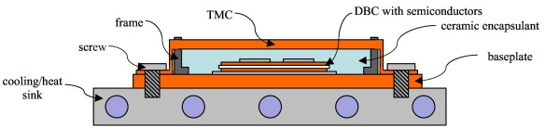

Fig. 9: Schematic of a power module with TMC [18]

## State of the Art Industry Module Designs

From the previous sections, there has been a discussion on the various aspects of the semiconductor packaging for electrification that pose challenges for electric vehicles. Several automotive companies are paving the way forward with innovative solutions. This section will cover some of the various methods that the automotive industry is taking to meet the different reliability challenges.

Hitachi has been a module supplier for the electric cars from General Motors, Mercedes Benz and Audi. Particularly, the inverter used in the Audi e-tron has shown a 160% improvement of power density compared to previous version [19]. Their modules are based on two Si IGBT devices forming a half-bridge rated at maximum 700V, 325Arms. The die interconnection is through Cu lead frame soldering. The 3rd generation Hitachi module employs double sided cooling bypassing the need for thermal grease and baseplate showing 35% improvement compared to single-sided cooling [20]. Cooling efficiency is further enhanced with resin and isolation sheets of high thermal conductivity between the copper lead frame and the heatsink. Similar to Hitachi, Toyota in partnership with Denso have used Si IGBT power modules with double sided cooling [21] . The die is connected with flip-chip solder to a Ni electrode. They have also developed modules with SiC packaging as well [22]. Another company that is using WBG devices is ST Microelectronics. They have provided SiC MOSFETs for Tesla Model 3 [23]. This package uses silver sintering technology for improvement in the thermal capability. The die attach is through Cu ribbon bonding and their cooling solution is through single sided cooling through pin fins.

Mitsubishi Electric is also developing power module such as the J series transfer-molded power module (TPM) for 60 kW operation [24]. Rather than wire-bonding, the module uses direct lead bond (DLB) for the die interconnection with Al wire-bonds only used for signal routing. An additional layer called the thermally conductive electrically isolated layer (TCIL) is placed below a heat spreader to increase heat conduction. With the direct solder connection of the chips on the heat spreader, there is improved transient thermal performance although they use single sided cooling. Among the various power semiconductor companies, Infineon is one of the most popular supplies for the EV industry. The popular HybridPACK module uses Si IGBT-based modules. The HybridPACKTM Drive [25]uses direct single sided pin-fin cooling while the HybridPACKTM DSC S2 employs double-sided cooling [26]. Some of Infineon’s modules have used diffusion soldering and Cu wire bonds with different substrate-to-baseplate joints. An innovative packaging solution is used by Nissan LEAF, where they solder the die directly to a buffer Cu-Mo alloy plate which is soldered to busbars [27], [28] . This method reduces CTE mismatch between the die and the busbar. The ceramic substrate, baseplate are replaced with a silicon sheet made with certain fillers between the busbar and the heat sink. A summary of the above-mentioned innovative solutions from industry along with other companies is given in Fig. 10.

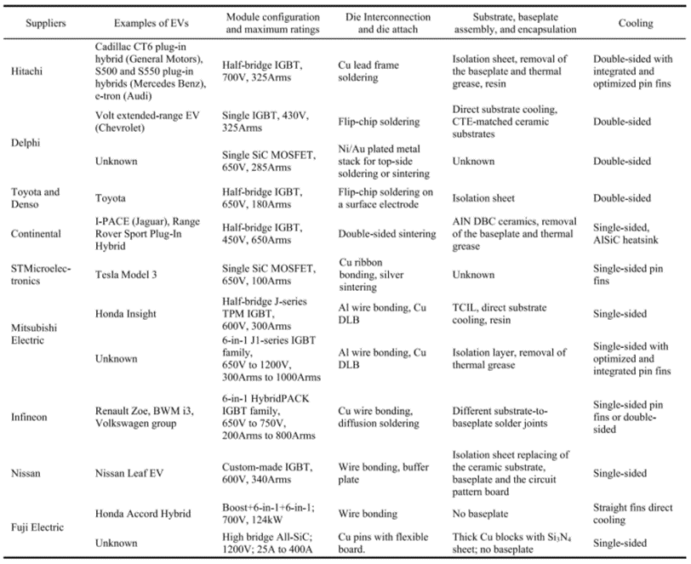

Fig. 10: Comparison of innovations in EV module design [9]

## Future Trends within EV Module Design and Implementation

From the previous section, it is seen that industry is pushing towards innovative solutions to accommodate packaging challenges. In order to realize extensive production of EV to lower costs, there are future trends in the packaging design that can improve common industry solutions. Although this section discusses different sub-sections of future packaging trends, most of these solutions are related and use different combinations of system integration. The key advantage of combining different solutions is that the disadvantage of one particular technology can be offset by the strengths of other technology which gives a net benefit in terms of packaging trade-offs.

### Transfer Molded Power Modules:

Demand for higher power and higher efficiency devices is driving the automotive industry to embrace Silicon Carbide (SiC). SiC have the advantage of a low on-resistance, good electrical performance, and ability to operate at high temperatures. SiC devices are also far smaller than their Si counterparts and thus allow for smaller designs to be realized. Traditional case-molded power modules are limiting in how small a design can be – primarily due to the structure of the case which is volumetrically inefficient. The case on standard case-molded power modules is primarily required for containment for silicon encapsulant material [29]. On the other hand, transfer molding allows for far smaller designs to be realized [30]. Transfer molded modules also provide many benefits, from improved reliability in thermal cycling, vibration and drop shock [29]. Studies have shown that such modules are more reliable in power cycling – thermal cycling where the device is turned on and off to simulate a usage scenario – as the molding compound reduced the stresses on wire bonds within a module [31]. Transfer molding is not limited to SiC systems. As shown in [32], silicon power modules also can benefit from transfer molding as it allows for smaller designs and modular implementation.

Another compelling case for transfer molded power modules comes from the reduction in device parasitics. Modules can be designed discretely to mitigate and eliminate performance-reducing parasitics. This reduction can be achieved by smart placement of positive, negative, and AC (output) terminals in the modules [33], or merely therefore that modules can be developed to be single or low-count power dies in a package, thus reducing power losses and increasing device performance [34],[35]. Additionally, molded devices provide options to be directly mounted on a heatsink, thereby eliminating the need for a case-mold heat-spreader and shortening the whole device thermal path [34],[35].

### Press-Pack Interconnects

Press Pack interconnects rely on pressure, rather than bonding by soldering, wire bonding, or sintering, to make electrical, thermal, and mechanical interconnects to dies. This technology eliminates standard die attach and die interconnect methods that are prone to failure. Press Packs are also advertised as being highly modular and simplified regarding fabrication and design. However, some issues have been identified, among which are the interconnections are highly pressure sensitive and require balanced and uniform pressure under thermal cycling to maintain good electrical contact [9].

There are a variety of methods to construct such modules. Press pack technology does not strictly require that all interconnections be achieved via pressure. For instance, power semiconductor dies can be attached to standard DBC substrates as in [36] and pressure applied to mate some interconnect structure to the topsides of the dies. Other implementations rely on compressible or deformable interfaces. Springs made from Beryllium copper or so called “fuzz buttons” from [37] deform as pressure is applied to built-up press-pack and press into the conducting surfaces of dies or substrates. Fuzz buttons from [37] are gold-plated beryllium copper wires compressed into a cylindrical shape. Due to this compression and the deformation during press-pack interconnection, current is carried through the plurality of “wires” within each button mitigating skin effects from high current switching.

Implementations from Semikron in [36] use a flexible PCB as the top side connection and using a shaped tool to contact dies in a power module. The dies in this configuration are attached via sintering or soldering to DBC substrates. Pressure is applied to the chips and substrate using silicon nubs and a shaped tool (Direct Press Die – DPD) to ensure good contact between the flex-PCB and the die surfaces. Such a pressing tool additionally reduces the thermal resistance from chip to thermal base-plate as the pressure applied on the DBC ensures good and close contact.

Press-pack modules as indicated in [9] are not impervious to failures modes. Thermal and power cycling can alter the pressures applied due to local or global deformations induced by the cycling. This change in pressure can result in an increase in contact resistance locally or complete loss of connection depending on the severity of the thermal excursion. Such interconnections are also sensitive to vibrations which are ever-present in an automotive environment.

### PCB integrated Power Modules : Arafat

Further reductions in system volume can be reduced if the chip is integrated with the PCB while also increasing reliability since the manufacturing difficulty is decreased with the well-established PCB process. In the EV power and voltage range, there is literature available for Si [38] and SiC [39] device integration with PCB. Two processes are shown in Fig. 11. One process includes embedding of the chips as a post-process after lay-up of the PCB laminate [40]. For PCB embedding, nano-silver sintering is common due to its high thermal conductivity and low CTE [41]. In this technology, conduction paths are created by the copper traces and vias instead of traditional wire-bonding. Higher glass-transition (Tg) temperature embedding material is required to ensure high-temperature stability. In addition, copper and nickel palladium metallization of the chip pad are preferred. Another form of system integration is possible where the device gate driver and a low-temperature co-fired ceramic (LTCC) inductor are packaged together in a PCB architecture [42]. With PCB embedding, there is lower parasitic inductance and resistance which reduces power loss and there is improved power density. However, there are some drawbacks with PCB embedding as the maximum operating temperature is limited due to the low Tg and high CTE of conventional PCB materials compared with those of semiconductor materials. In addition, for example, FR-4 PCB laminates have a lower bonding or peel strength compared to a DBC board. Because of these limitations, the current PCB embedded modules are limited to lower power (< 50 kW).

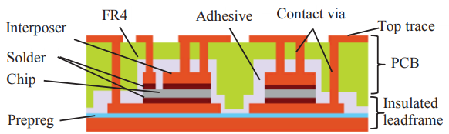

(a) PCB Embedding with the chip in the middle [25]

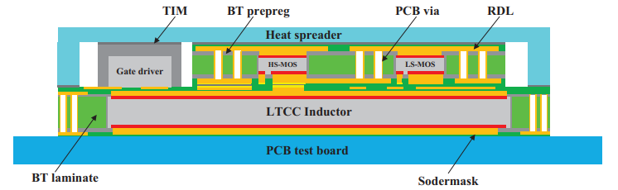

(b) PCB Integrated Power Module with LTCC inductor and gate driver [27]

Fig. 11:Examples of PCB integration of power modules

### 3D Packaging and Advanced Materials : Arafat

Better thermal design and system integration is possible with the 3D packaging structure. Most of the future trends discussed in this section are associated with 3D packaging. One common application of 3D packaging is double sided cooling where the top side wire-bonding is substituted with copper clip or other planar connections [118,120]. In addition, chip on chip packaging (CoC) and embedding of stacked chip structure into PCB can improve the EMI coupling and lower mechanical stress respectively. There are clear benefits of 3D packaging for power modules, however, there are also added challenges. The overall design complexity increases adding to possible issues with manufacturing and reliability. In addition, custom 3D packaging designs need to pass the automotive requirement standards. As EV systems undergo rough operating conditions, the choice of material is important to have good thermal and mechanical properties. There is ongoing research looking at novel materials for packaging. In [127] Cu-Sn IMC can achieve higher remelting temperature than Pb-Sn, which enhances the stability of bonding under high temperature. Encapsulants are also an issue with high-temperature application. [128] concludes that Polyimide, bismaleimide, and cyanate are suitable for high-temperature applications due to the high Tg, although the high CTE is challenging for mitigating thermal stress.

# Autonomous Driving

## Introduction to Autonomous Driving

### Definition with SAE Level Summary

Autonomous driving, also known as self-driving or driverless cars are vehicles that are fully automated with little to no human interaction [43]. These vehicles use a combination of sensors and computers to read the environment and control the vehicles motions in the environment [43]. These autonomous vehicles have many benefits. The automation can potentially prevent vehicle accidents, reduce traffic, increase mobility freedom, and reduce fuel consumption protecting the environment [44] [43]. While there are benefits, there are also safety concerns with autonomous driving. Since the human will have zero control of a fully autonomous vehicle, the vehicle itself is responsible for the passenger’s life. This immense responsibility of the vehicle makes autonomous driving design and manufacturing very difficult [43].

### Current Autonomous Vehicle Industry

As of 2020, there are no self-driving cars available to consumers in the United States, however, many companies are in the process of designing and researching autonomous driving vehicles. The market for autonomous vehicles is projected to be near 3.8% of all cars on the road in 2030 at around 4 million vehicles [43]. The companies pursuing autonomous driving range from traditional automakers like General Motors, Audi, BMW, Toyota to electric car manufacturer Tesla to technology companies Google/Waymo and Uber. Autonomous driving requires a wide range of technology fields including electronics, vehicle dynamics, and software to work together [43].

### Society Automotive Engineers (SAE) Autonomous Driving Levels

While autonomous driving is still years away, there are timelines and milestones to get to fully automated driving predicted by the Society of Automotive Engineers (SAE). The SAE currently has six levels of driving modes. The first level is level 0, this is where the human performs all the driving tasks without any aid. Level 1 is when a single aspect of driving such as speed or acceleration is controlled by the vehicle and not the human [43]. An example is cruise control. The vehicle controls speed, while the human controls the steering. Level 2 is when the vehicle can control multiple items at once [43]. An example is automated parking by vehicles. The vehicle can control the steering and speed to park the vehicle properly. Level 2 requires the driver to be involved and pay full attention to the vehicle. Tesla Autopilot is another example of SAE level 2. Level 3 is classified as when the human does not need to focus on the driving tasks [45]. Or in other words, the human can focus on other tasks instead of driving such as sending a text message. However, level 3 requires the human to take over when needed for safety. Level 4 is considered automated driving except on occasional needs [43] [46]. In other words, the human can safely not pay attention and the vehicle can transport them. However, there can be situations where programming cannot be used if the human must take over. The difference between level 3 and 4, is the vehicle can recognize that it cannot complete the mission in level 4. In level 3, the human have to intervene to stop the vehicle. The last level is level 5, fully automated driving [43]. This is where the human will never need to intervene. This would allow people who cannot drive, such as children or senior citizens, the ability to be mobile without ever needing to control the vehicle. A summary of the SAE level can be found in Appendix A.

### **SAE Autonomous Driving Level Timelines**

Currently in 2020, the highest SAE level of vehicles available to consumers in the United States in SAE level 2. The industry has a long way to get to SAE level 5, however timelines and milestones have been predicted [43]. It is predicted with current technologies that SAE level 3 will be reached in the near future of 2022. In the next 2 years, SAE predicts various chauffeur capabilities from vehicles during traffic jams and on the highway [43]. The vehicle will be capable of moving itself, but the human would need to be aware if they need to step in. SAE milestones for level 4 are not as optimistic. Level 4 would consist of highway autopilot and city driving capabilities where the human can have their mind off the vehicle and complete other tasks. A summary of the SAE timeline and milestones are seen in Fig. 12.

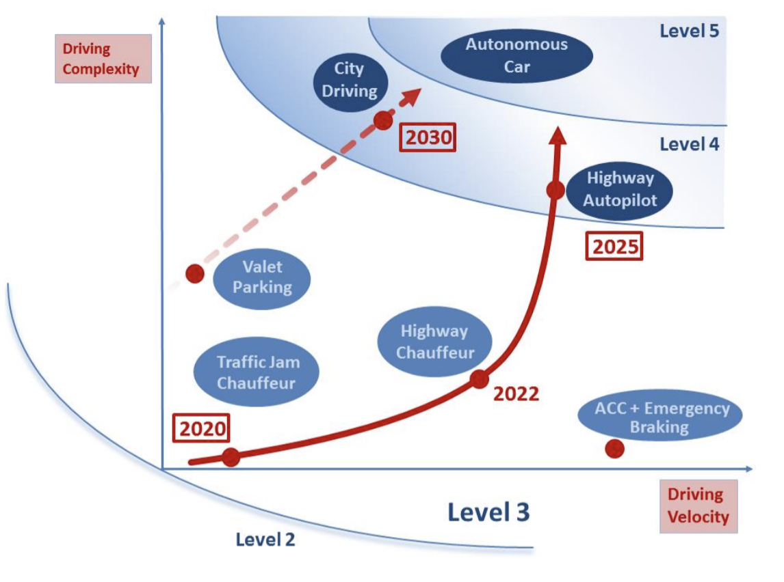

Fig. 12: Timeline with milestones to achieve SAE level 5 [43]

## Packaging Challenges

### **Requirements and Challenges**

Semiconductor packaging is affected by the development of autonomous driving technology from different aspects. Due to all the driving decisions made by the car itself like accelerating, braking and steering according to recognizing the environment situation and dealing with the “big data”, a large number of sensors, controllers and power modules will be necessary. To achieve higher and higher automation levels, stronger demand for ADAS is needed to support this upcoming high-performance sensing and massive computation. As the required power goes higher and sensing technology becomes more advanced, semiconductor packaging technologies in complex systems also need to be more integrated.

#### Miniaturization Challenges

Both the numbers and types of semiconductor chips will increase significantly for autonomous driving considerations, therefore, strict requirements on power density and automotive reliability will become a challenge in miniaturized packages. Here are some examples showing the significance of miniaturization and how it is applied to meet the autonomous driving related standards [47].

Flip-chip attachments on packaging can achieve great improvements in shrinking the footprint area and shortening the interconnect length over conventional wire bonding packaging by facing the chip down. There is intensive research on optimization of the bump design, bump layout etc. to improve the reliability performance caused by the CTE mismatch challenge in flip-chip attach packages to meet the standard in automotive applications even in high ambient temperature.

Another example of miniaturization is the application of semiconductor component integration. Electrical power steering (EPS) unit in ADAS contains multiple half-bridge MOSFETs circuits serving as power switching devices. As a critical control module in autonomous driving systems, a redundant EPS system would be needed to guarantee the safe operation in the driving so that there will be backup under all situations in case one of the systems fails due to various reasons. With the need for redundant systems in ADAS, an integrated half-bridge solution would be a good example in packaging miniaturization to save board space as well as minimize parasitic loss.

#### Thermal Management Challenges

Heat dissipation is another important topic when managing increasing power densities with the development of more and more functionalities. A practical heat solution example to avoid thermal overload is top side cooling (TSC) which dissipates the heat to the top instead of to the bottom and into the PCB. TSC is easy to achieve for lead packages and can effectively reduce the thermal resistance compared to bottom-side cooling systems [47]

#### Connectivity

Autonomous driving can be enhanced by information from connectivity. With connectivity to other cars and infrastructures, the driver can receive warnings of hazardous situations even if these are not within the sensor range. Connectivity related packaging challenges will be introduced detailedly in the following sections [48].

### ADAS Processors

ADAS processors with advanced Si nodes and higher powers significantly improved the performance of the control unit. To achieve the advanced ADAS functionality, higher semiconductor transistor density and integrations between multiple Si nodes and multiple chips are required and will bring challenges to packaging technologies. Advanced packaging is needed as well as cost needs to be lowered in order to enable the use of massive amounts of transistors for complex algorithms [49]. Fig. 13 shows the automotive processor roadmap [49].

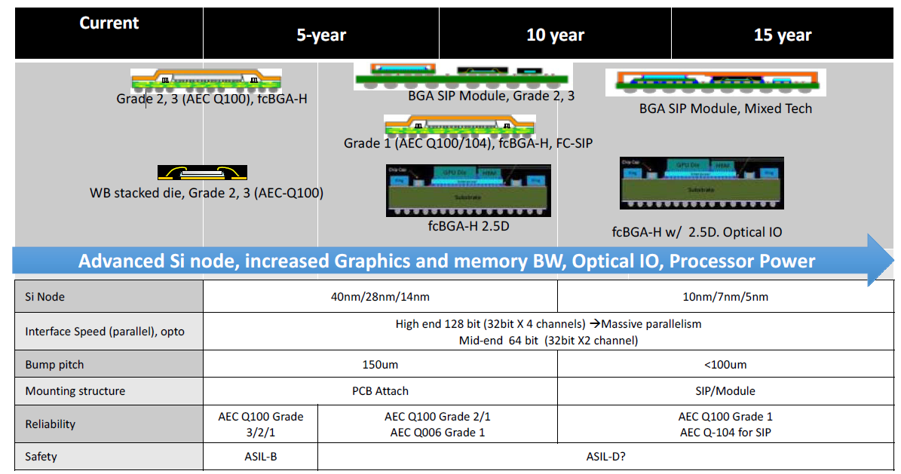

Fig. 13:Automotive processor roadmap [49]

#### State of the Art and Trends

Generally, in traditional packaging choice of ADAS processors, wire-bonding is still the common interconnect and SoC is still the common architecture. While flip-chip interconnects are being applied. In the short term, performance improvement requirements will demand much higher bandwidth and even higher thermal performance. Cu pillar interconnect, multi-die packages and stacked dies will be used for higher density integration. Advanced thermal techniques will be needed for heat dissipation. In more long time, new packaging structures with heterogeneous integration will be applied for the processor computational performance.

#### Packaging Challenge and Reliability Targets

With the requirements on computational ability and bandwidth, packaging is developing towards the integration of different silicon products and 3D architectures. Increased footprint area due to the SiP integration is bringing thermal and thermo-mechanical challenges. Redundancy of function is important in the function safety of ADAS, which challenges reliability and lifetime with the need of technology update. Increased operational hours due to autonomous driving will change the reliability expectations of semiconductor components.

### Sensors

Sensors are one of the key components in ADAS and fully automated driving will even greatly rely on sensor data to navigate the vehicle in the road. A variety of different sensors, shown in Fig. 14 enables the vehicle to detect the surrounding traffic, road conditions and other environment situations to help the autonomous system make decisions in especially level 4-5 autonomous driving systems. Different types of sensors provide specific functionalities in specific areas and complement each other through sensor fusion technologies to create the most accurate, complete image of the surroundings. Most significant and most commonly used sensors including radar, LiDAR, video sensors (cameras), and ultrasonic sensors. Ultrasound sensors detect obstacles in situations such as parking and are already widely used in ADAS. Other types of sensors and their related packaging technologies will be introduced in the following sections [50].

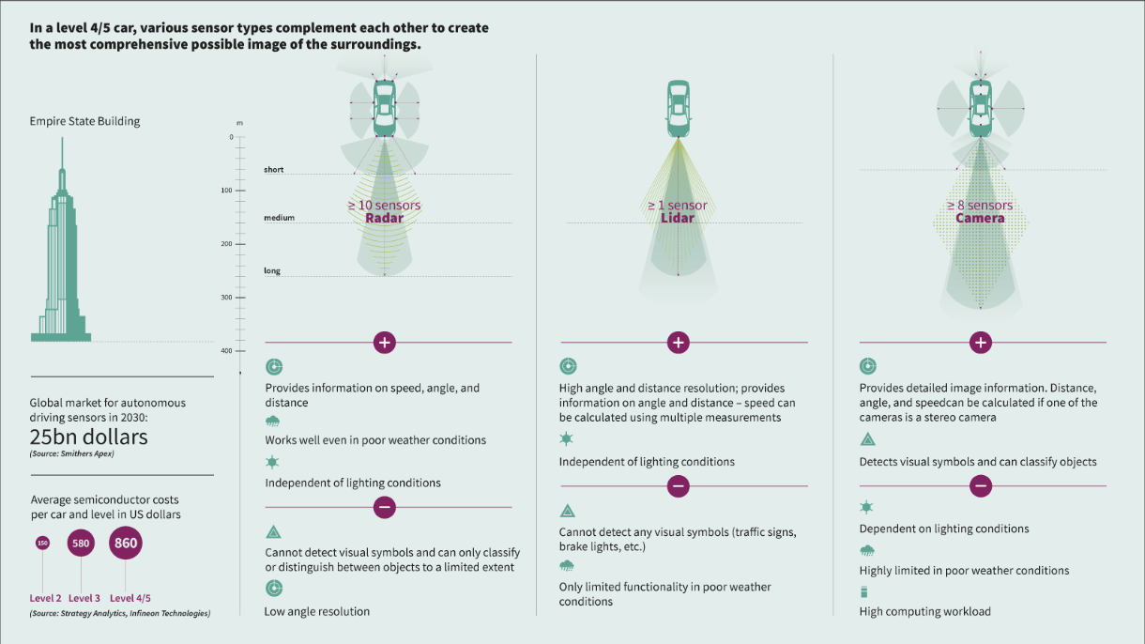

Fig. 14:Comparison of different automotive sensors [50]

### Radar

Radar sensor technologies have been established over the past decades as the most fundamental sensor components in ADAS. Radar sensors can detect in relatively long distances, measuring information on distance, speed, and angle relative to the vehicle, which enables ADAS to sense the surroundings in great detail. Radar sensors have lower range and angular resolution is poorer compared to LiRAR, but it also works well in bad weather conditions. Thus, the performance and reliability of radar sensors is of great value in autonomous driving where other sensors are likely to fail [50] [48].

Radar sensors measure position and speed of objects by transmitting high-frequency electromagnetic waves through Doppler effect. Current radar sensors are usually 77GHz (long-range radar applications) or 24GHz (high-resolution and short-range radar) with a bandwidth of 0.1 - 1 GHz. Most of the existing radar systems use several Monolithic Microwave Integrated Circuits (MMIC) based on GaAs with the consideration of operation frequency, while cheaper SiGe solutions are getting into manufacture more and more. New radar systems are also moving toward more and more integrated into single chips through BiCMOS technology to merge digital parts into the analog parts in one single chip [51].

#### eWLB solutions for radar chips

The impact of semiconductor packaging on the electrical performance of the chips becomes more and more significant when the frequency is increasing beyond 10 GHz. Besides the material considerations and integration technology, there are other packaging technologies in great progress regarding miniaturization, reliability and cost. Traditional packaging solutions (mainly wire-bonding and flip-chip packaging) have been used for radar chips, while embedded wafer level BGA (eWLB), shown in Fig. 15, starts to lead for radar transceiver chips.

Fig. 15:Cross-section drawing of an eWLB package for radar chips [51]

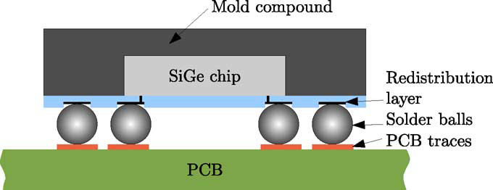

eWLB technologies were introduced for mobile phone chips first based on the idea of using interposers or redistribution layers (RDL) to reduce the requirement of PCB technology to match with the shrinking of pad size. eWLB is a promising solution for mmWave radar applications due to its advantages in small interconnect length, low conduction and dielectric loss, small parasitic electrical interference, and good design flexibility. eWLB is possible to minimize the interconnect length and shows excellent electrical performance in mmwave frequency range. It can achieve a remarkable packaging size reduction compared to wire-bonding and flip-chip solutions due to its slim and smaller form factor. eWLB with a very thin RDL also enables flexible design. In addition, eWLB also provides a versatile platform to both horizontal and vertical layouts through RDL interconnection and TSV technologies, which makes progress into future integration toward 2.5D interposers and 3-D SiP configurations.

### LiDAR

One of the leading technologies to analyze the surroundings of the vehicle is lidar. Lidar is the use of light to map out an environment. The basics of lidar consist of two primary components: the laser transmitter and photodetector. The laser transmitter emits a light signal, which bounces off objects in the environment, and comes back to the photodetector over a specific timeframe. Using the time between when the light was transmitted and received, the distance between the vehicle and various objects can be calculated. A breakdown of this example can be seen in Fig. 16. Using a rotation device with multiple angles, a single lidar device can map out a 360° area around a vehicle. With a mapped environment, algorithms are being developed to determine physical descriptions of the objects and using velocity to predict object’s behaviors. Lidar systems are very popular in autonomous driving systems and are projected to be the dominant technology in making autonomous driving possible [52].

Fig. 16: Electronic parts of the LiDAR system [52]

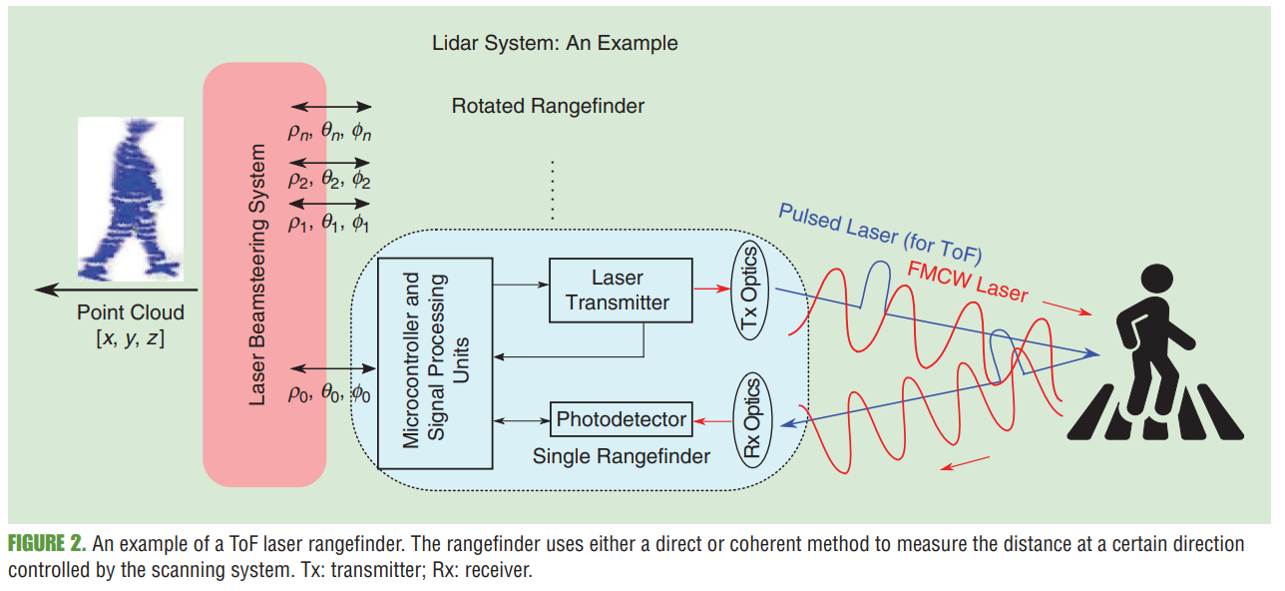

There are two popular versions of laser transmitters used in lidar. One is edge-emitting lasers, which are common in telecommunications. These lasers transmit a plane perpendicular to the laser out like an oval shape. Vertical-cavity surface-emitting lasers (VCSEL) transmit a circular shape increasing the resolution and it is smaller resulting in less space occupied [52]. The lasers are stacked on one another with MOSFET transistors controlling them. The VCSEL use diode stack technology to save space, however, the proximity to one another results in heat dissipation problems [17]. Heat sinks are a common solution for laser heat dissipation.

There are several types of photodetectors used in lidar. The photodetector depends on the laser light source wavelength. Common photodetectors include p-i-n photodiodes, avalanche photodiodes (ADP), single-photon diodes (SPAD), and Si photomultipliers (SiPM) [52]. ADP is superior to p-i-n photodiodes because they have less noise. SPAD is a step up to ADP because it can detect weaker light waves that ADP cannot detect. SPAD is a desirable choice because it has a good balance of resolution with low cost and low power consumption. SiPM is a step up from SPAD because it can interrupt the magnitude of a photon to gain more information, however it is more expensive. The vehicle requires a 360° area around the vehicle, therefore the lidar system must somehow rotate or move to capture the whole environment. The most common solution is mechanical spinning. Mechanical spinning is using a controlled motor to rotate a mirror or prism [52]. An example of the mechanical spinning system is shown in Fig. 17. The lidar device is stationary and does not rotate. The mirror or prism is above the lidar system and rotates while emitting reflected light to the lidar device below. A problem with mechanical spinning is the bulky shape found on top of autonomous vehicles [52]. This bulky shape is difficult to minimize with the current technology and is vulnerable to rain and water on the roof of the vehicle [52] [48]. Another reliability concern is the alignment of the mirror/prism when experiencing vibration [52]. Vibration is very common in automotive applications. New technology is emerging to build a stationary lidar device. Using magnetics fields and various optical emitters, it is possible to have no rotating parts in the lidar system and map a 360° area around the vehicle [52]. The problems with these stationery lidar systems are less range in terms of distance and worse resolution when compared to mechanical spinning devices.

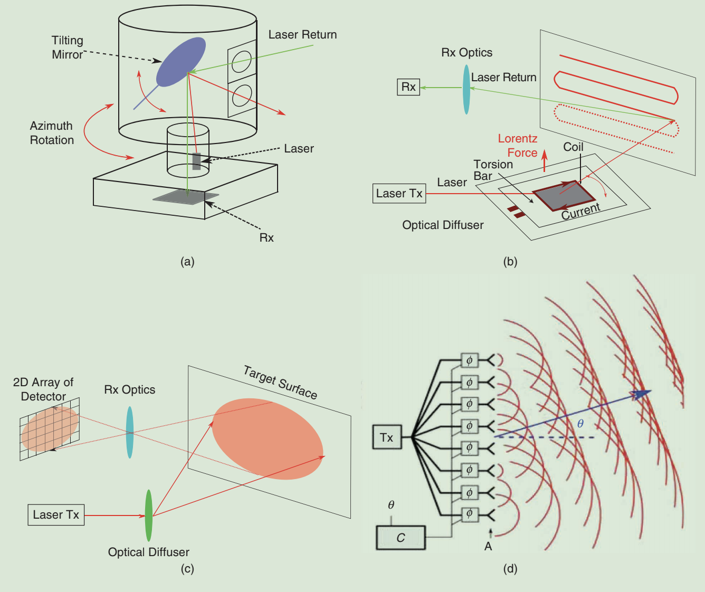

Fig. 17:Example of mechanical spinning LiDAR system [52]

Lidar systems are already being implemented in vehicles and will be more common in vehicles as the lidar systems become lower in cost. The first automotive-grade lidar system commercially available on a vehicle was the Audi A8 using a four-layer mechanical spinning lidar system. Audi A8 was the first vehicle to be considered SAE autonomous driving level 3.

### Camera

Camera technology has been around for over one hundred years and has become a common entity of our lives. In automotive, cameras have become very popular in the last decade in assisting parking [18]. Cameras are most common at the rear of the car, assisting the rear-view mirror. Cameras are also being used along the front bumper for parking and along the sides of the vehicle. These systems have been proven to be very effective and reliable [53].

In autonomous driving, cameras are very popular in object recognition. It is common to use cameras as an additional sensor to the autonomous vehicle system. For example, the Tesla Autopilot self-driving feature uses 8 cameras with a radar system [54]. Cameras can be set up in different locations on the vehicle and have different focal points and field of views to detect objects at different distances [55]. The cameras can detect objects such as pedestrians, traffic signs, and other vehicles and using multiple cameras can determine a depth estimation of the objects. Camera technology is miniaturizing to save space in the vehicle [56]. This has led to wafer-level camera technology. This technology replaces an image sensor being bonded to a PCB which can become an expensive process due to the image sensor needing to be protected in a clean room before bonding to the PCB [57]. Wafer-level cameras are manufactured from glass to air to sensor to die to the ball grid array. This structure is shown in Fig. 18.

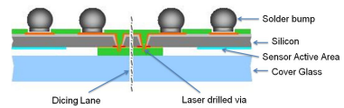

Fig. 18:Wafer-level camera cross-section view [57]

This structure allows the optical sensor to be protected during the beginning of the manufacturing process and shorter time in a clean room facility, resulting in lower costs. This manufacturing process allows ball grid arrays to be produced resulting in large amounts of interconnects and can be completed at quick speed saving costs. There are also reliability benefits because the coefficient of thermal expansion for the glass and wafer material are similar resulting in less stress from thermal expansion [57].

### Software

Prognostics and health management (PHM) is a technique to predict and maintain an electronic system's health [58]. The goal of the PHM is to predict electronic and mechanical failures before they happen. This is important in automotive because failure during the act of driving can lead to serious injury to passengers or bystanders of the vehicle. The PHM requires an algorithm based on a large dataset to predict when various parts are nearing the end of life based on various monitored parameters [58]. Examples of PHM monitoring in automotive electronics are shown in Appendix A.

As automotive vehicles become more complex in the transformation to autonomous driving, there is more electronics to monitor. Autonomous vehicles must have large historical datasets and prognostic algorithms to predict potential failures in autonomous driving vehicles [58]. Failure to correctly predict failures electronics for a SAE level 4 or 5 autonomous vehicle can be catastrophic because the human at those levels is not paying attention to the vehicle. The increase in electronics has also led to a paradox of electronic failures. As automotive increases electronic complexity, they also increase the amount of failure points. A figure in Appendix A shows the percent of automotive failures from 2005 to 2015. As autonomous driving capabilities increase, it is expected that the number of electrical faults will increase [59]. PHM will need to account for these large amounts of electronic faults for the safety of the passengers.

# Vehicle Connectivity

## Introduction

### What is automotive connectivity?

Connectivity is an important property developed for modern automotive’s comfort and safety. Intra-vehicle connectivity provides significant support for infotainment and communication inside the vehicle’s electronic control system. “Car-to-anything (C2X)” communication enables the enhancement of autonomous driving by acquiring information of surroundings from the sensors in other vehicles, the traffic infrastructure, and traffic control systems, etc. Drivers can also be warned remotely of hazardous situations such as bad weather or traffic conditions even if they are not in the sensor’s range [47] [50].

Accessing the internet via various channels such as special automotive Wi-Fi or 5G mobile network and receiving information from smart devices, other cars, and infrastructures will form “swarm intelligence” to collect real-time data from different sources to help drivers, passengers as well as the control system itself [47]. Fig. 19 shows examples of automotive connectivity.

Fig. 19:Examples of connected cars [47]

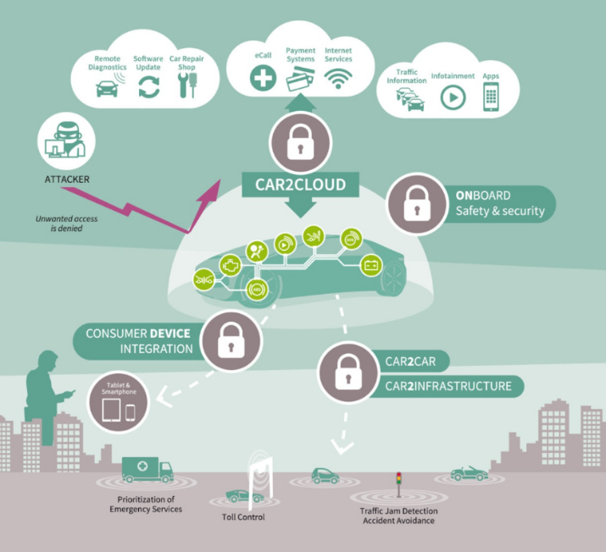

*Intra Vehicular Connectivity*

Intra-vehicle connectivity means the data exchange within the vehicle and is usually completed in the electronic control unit. Multiple infotainments and other vehicular applications are enabled through intra-vehicle connectivity providing more comfortable and more intelligent driving.

Controller Area Network (CAN) protocols were developed in the 1980s for lower speed control applications. Higher speed communication through Ethernet protocol becomes the major selection until the 2010s enabling navigation applications. Gigabit Multimedia Serial Link (GMSL) has emerged since 2017 providing a 30 times faster data rate than automotive Ethernet with the increasing need for more powerful infotainment and ADAS processors [49].

#### Vehicle to Everything (V2X)

Vehicle-to-Everything (V2X), including vehicle-to-vehicle (V2V), vehicle-to-infrastructure (V2I), vehicle-to-roadside (V2R), vehicle-to-pedestrian (V2P), etc., enables vehicles to broadcast and receive information about the locations, speed, and direction wirelessly. Proper messages from other vehicles, pedestrians, road-side equipment, and the internet can help determine the potential danger and provide useful driving suggestions. [49] [50].

Either wifi-based or cellular technologies can be implemented in V2X communication. Dedicated short-range communications (DSRC) technology developed specifically for V2V applications has been widely tested and used in large-scale trials. Cellular-based V2X communications have already been standardized by 3GPP [49].

### Hardware challenges and important problems in connectivity

With the emergence of the Internet of Things, the automobile industry has witnessed massive growth in the embedded systems market due to the speedy development of connected devices [60]. The embedded intelligent connectivity continues to increase at a phenomenal rate as a result of the Internet of Things. This rapid development of connected devices with the application in automotive imposes some hardware challenges which are discussed below.

#### Lifecycle Mismatch between Consumer Electronic devices and car

Vehicle Manufacturers have been facing a lot of challenges because of the dramatic mismatch between consumer handheld devices and automobiles in terms of product lifespan and speed at which new updates and features are introduced [61]. One solution to ensure success is providing a secure and accessible method to update a vehicle’s infotainment system software consisting of better features and new content. The challenge that lies in front of the Vehicle Manufactures is to incorporate configurable and interactive internet-based content in future cars, which requires transitioning from traditional analog audio systems that served up broadcast content [62].

#### Need to update/extend the InVehicle Infotainment system software

InVehicle Infotainment is a combination of vehicle systems used for delivering entertainment and information to the driver as well as the passengers [62]. These systems work in integration with in-vehicle and external systems to deliver entertainment and information through audio/ video interfaces, control elements like touch screen displays, button panel, voice commands.

The main components of in-vehicle infotainment system are [62]:

* Integrated Head unit- Head unit acts as a control system for the infotainment system and is mounted on the vehicle’s dashboard.
* Heads-up display- Heads-up displays are used for displaying vehicle’s real time information on the screen integrated with the vehicle’s windshield. These systems have become an integral part of the infotainment system as they help the driver to keep track of key details like speed, navigation maps, electronic digital cluster (information from vehicle’s OBD port-II), climate, multimedia options without getting distracted.
* Operating systems- Operating systems like Android,Linux,QNX and windows provide in-vehicle infotainment systems with connectivity, convenience functions, and downloadable software applications to integrate new functions in the system.
* Controller Area Network- These communication protocol systems allow micro controllers and other devices to communicate with each other in the absence of a host computer.
* Connectivity Modules- Services like navigation, internet connectivity and smartphone integration with the infotainment system to improve connectivity between external networks and devices are established by modules like GPS, WIFI and bluetooth.
* Automotive Sensor Integration- Different types of sensors such as Proximity sensors, gesture recognition sensors for detecting ambient light, camera sensors are mounted onto vehicles to provide safety related information to the passengers.
* Digital Instrument Cluster- Digital Instrument Clusters fetch information from the vehicle ECU unit and have replaced the traditional analog gauges with digital display screens for speedometer, RPM, odometer.

With increasing demand for highly customized in-vehicle infotainment systems, Vehicle Manufacturers are focusing on designing feature-rich, versatile, and powerful processors [62]. High performance processors are required to assist with high level of computing and intelligence in vehicles.The continual increasing performance of microelectronics products places a high demand on packaging technologies. Key drivers such as thermal management, power delivery, interconnect density, and integration require novel material development and new package architectures. This section will talk about the package technology challenges and migrations for microprocessors and strategies to address these challenges [63]. Fig. 20 shows the architecture of inVehicle infortainment system.

Fig. 20: IVI System Architecture [62]

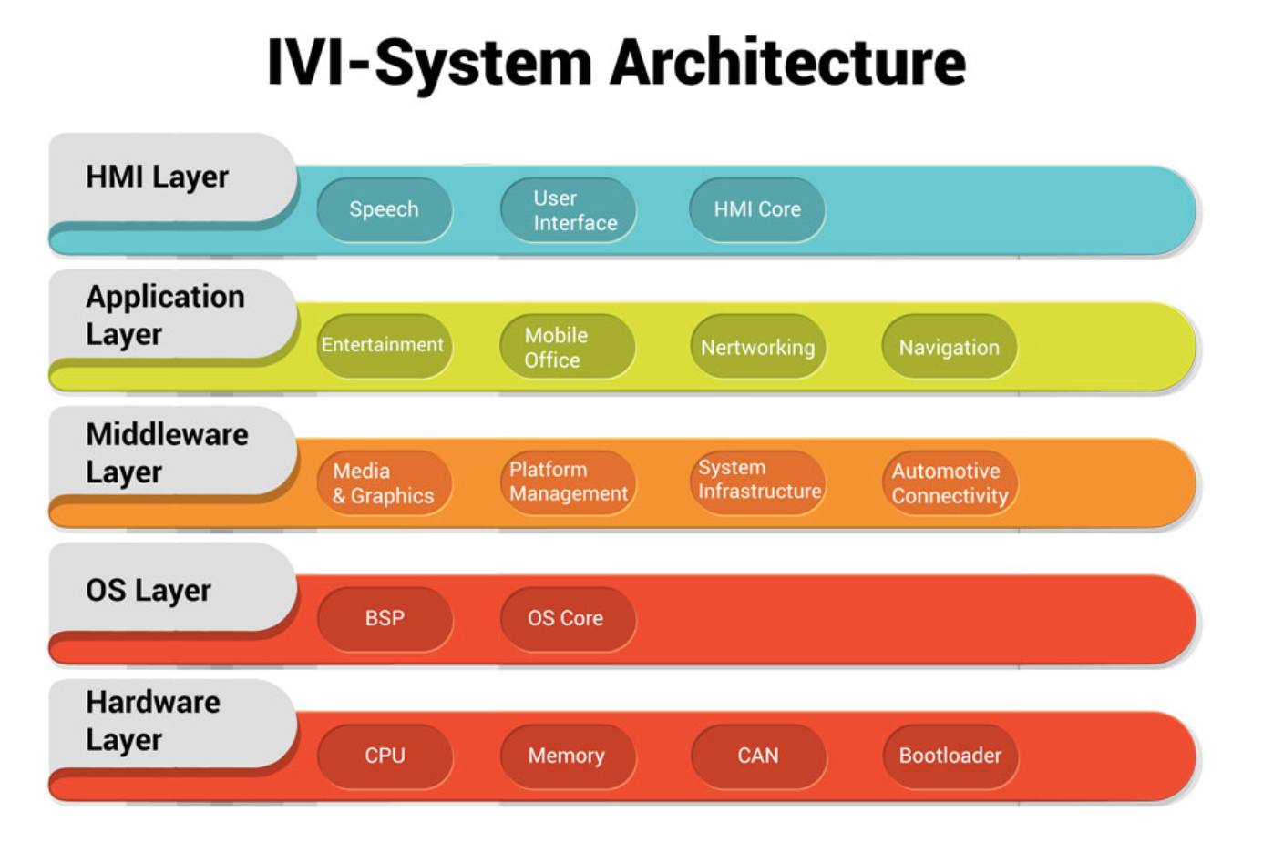

## Packaging Challenges

### General Packaging Requirements

#### Operational time

Connectivity drives the increased requirement on the operational time of packages. With the ubiquitous entertainment devices that interact with cars, software usage through local wireless networks, etc. the infotainment processors and other related electronic device require high-performance capabilities for longer operational time [47].

#### Speed and Frequency

High speed and low latency are critical in real-time communication and information processing for driving determinations. In addition, with the trends of higher bandwidth, there are increased packaging requirements regarding power and thermal dissipation [64]. Fig. 21 depicts the frequency band of different communication applications.

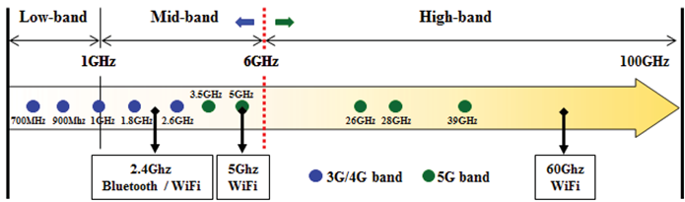

Fig. 21: Different application of frequency band [64]

*Volume*

Miniaturization and integration of semiconductor packaging are one of the key requirements for all types of automotive applications. Advanced packaging, such as SiP and small Si node chip technology will be used in applications related to connectivity. eWLB technology developed for wireless applications can also find its way into automotive communication.

#### Data safety

Data security is critical in V2X communications. Undisrupted communications must be provided to protect users’ information to deter tracking and tampering. Network technologies like firewalls and gateway are not in the scope of this report. But data security does increase the packaging reliability requirements in various ways [47].

### Packaging Challenges and Related Technologies

Packaging industry is moving towards advanced packaging processes such as flip-chip or wafer level fan out packaging due to the requirement of continual increasing performance of microelectronics products [63]. In order to meet these demands of higher complexities and better

performance, microprocessors require greater number of pin counts in sockets, thicker copper wires and advanced packaging techniques. Fig. 22 shows the typical semiconductor package roadmap for automotive applications.

#### Standard wire bond and Flip chip packages

Fig. 22:Typical IC packages roadmap for automotive dashboard applications [63]

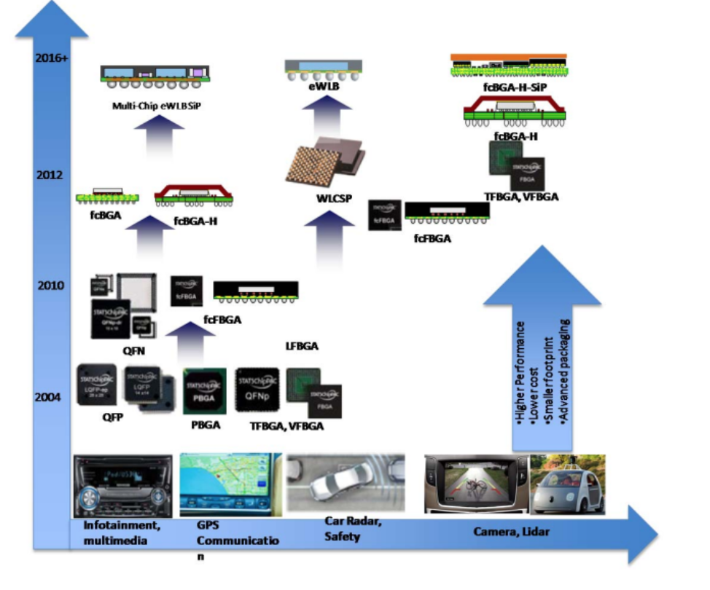

Wire-bond packaging technology consists of a junction/die that usually connects to a thermal pad for heat dissipation. The junction has bond wires to connect the junction to the pins. The bond wires are very thin resulting in most of the heat escaping from the thermal pad [63]. Flip-chip technology on the other hand, flips the chip/junction so that the copper bumps are upside down and soldered directly to the lead frame. This results in reduced impedances from the pin to the junction, improving efficiency, size, switch ringing, and overall performance of a chip. The flip chip process is lower in cost than the conventional mounting technique, because it eliminates the high cost and low process yields of wafer thinning and via formation while simultaneously improving the visual inspection yield by reducing wear and tear on the frontside of the chip caused by backside processing [63]. Furthermore, an entire manufacturing process (wire bonding) is eliminated, reducing manufacturing capital and support costs as well as wire bond yield losses. Fig. 23 [65] shows the comparison for face-up wire bonding technology and flip-chip technology.

Fig. 23:Flip chip technology eliminates wire bonds and enhances chip and assembly yields[65]

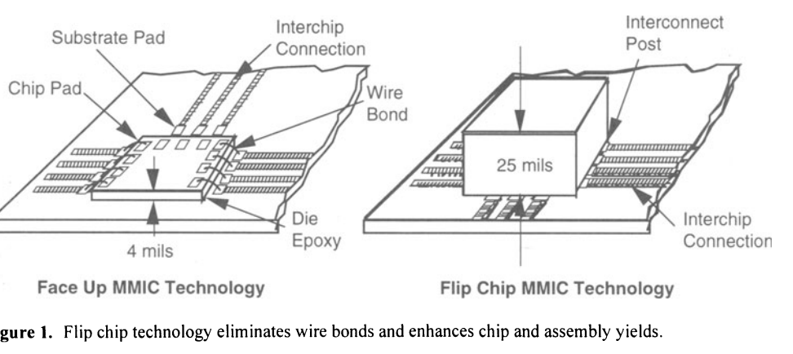

#### Fan-Out-Wafer-Level Packaging

Advances in packaging have allowed companies to improve the thermal characteristics, and improve the electrical performance of their systems. Fan-Out Wafer-Level Packaging (FOWLP) is an emerging advanced packaging process that offers an improvement over wafer-level packaging (WLP), and was developed to provide a greater number of external contacts with a silicon die [63]. FOWLP is a robust method of manufacturing and it eliminates the size constraint of a normal die thereby allowing a larger number of connections between the package and application board. FOWLP involves dicing the wafer into chips and embedding these chips into a low cost material such as epoxy molding compound. The dicing of wafer is followed by application of Redistribution layer on the glass or silicon substrate which provides more room to attach solder balls [63].The design flexibility of this method allows for integration of multiple dies and passives and is becoming an attractive solution for thinner profile and higher level of integration packages in a wide range of applications. Fig. 24 shows the evolution for FOWLP.

Fig. 24:Evolution of Fan out MCM-Sip [63]

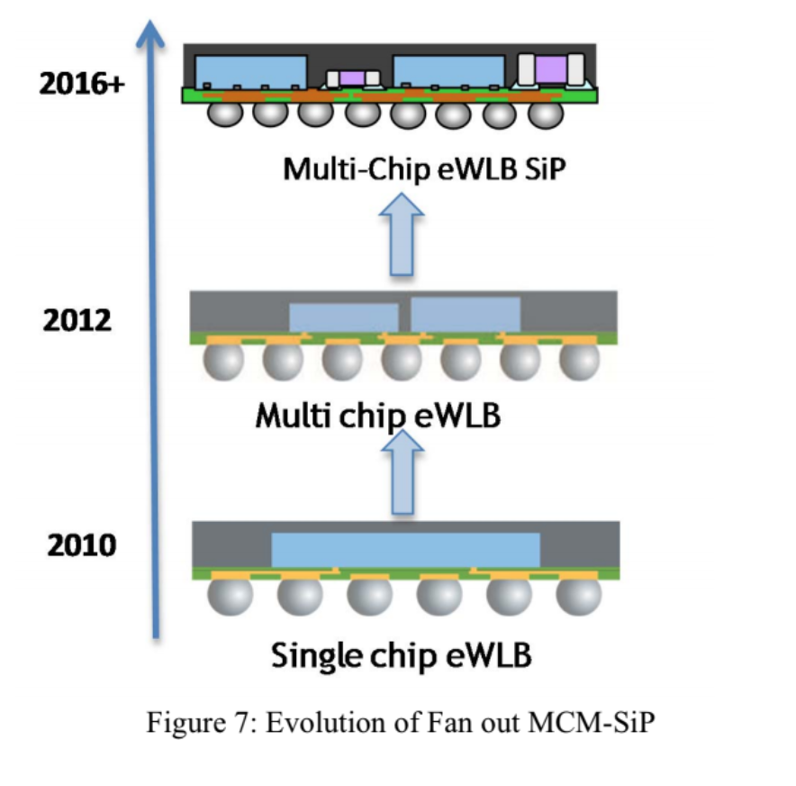

### 5G communications

Compared to 4G and 4G LTE, the fifth-generation mobile communications have higher data rates, lower latency, higher bandwidth, and connection density. 5G architecture is an important solution for V2X connectivity as ultra-reliable low latency communications (URLLC) as stated in 3GPP Release 15 [66]. Fig. 25 shows examples for 5G use case supporting V2X connectivity.

There are great challenges for the packaging requirements for 5G communications. The low element-to-element spacing requirement in high frequency means further integration and size reduction will be needed. As more frequency bands and higher frequency up to mm-wave are required for 5G to improve performance, more complexity in 5G communication will need higher levels of component integration, which will be the key driver of heterogeneous integration technologies. The research and development of 2.1D, 2.5D, and wafer-level fanout techniques should be increased. [49], [66], [67].

Tight integration of mm-wave active electronics, filters, and the antenna is critical to 5G RF Front-Ends. Antenna in Package (AiP) and Antenna on Chip (AoP) technologies allows higher-level integrations for antenna and the active components. For mm-wave front-end modules, monolithic integration of system on chip (SoC) by integrating analog, RF, and digital blocks. With the need for finer-pitch I/O between chip and packages, there will also be more opportunities for SiP architectures including the optimization of flip-chip and fan-out WLP. [49], [66], [67]. Fig. 26 shows the SiP atchitectures in 5G mmWave.

Fig. 25:Example of 5G Use Case Supporting C2X10 [66]

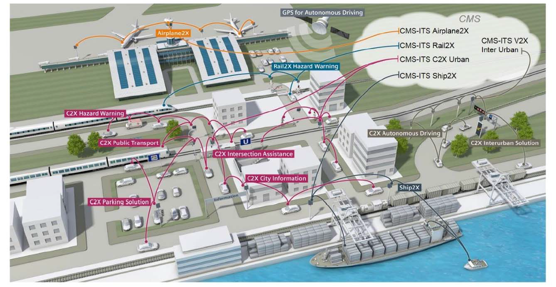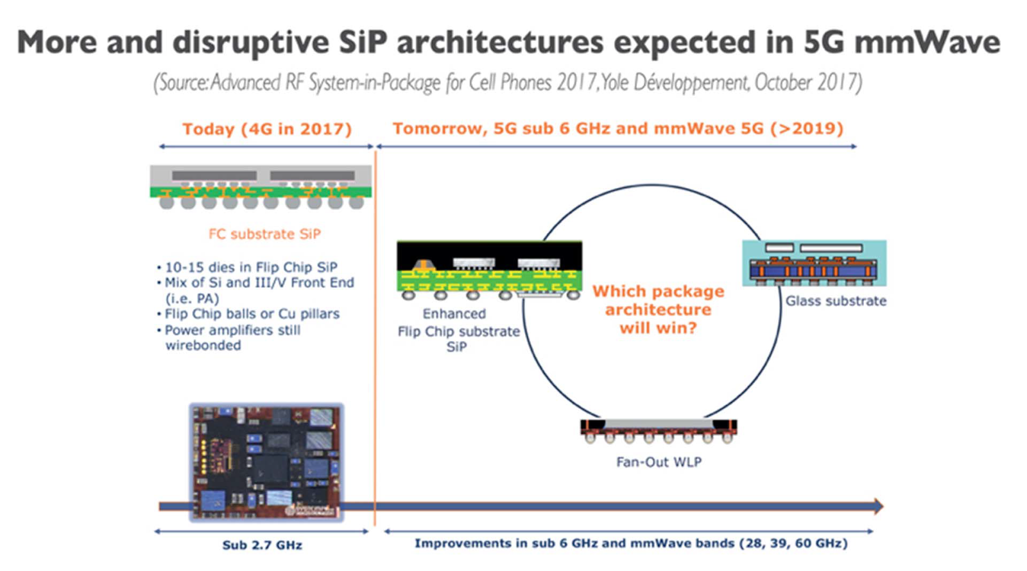

Fig. 26:Disruptive SiP Architectures expected in 5G mmWave [66]

### Connectivity Processors

To make use of the information provided by V2X connectivity and help autonomous driving systems make decisions, the ADAS processor is the most significant component. In addition, infotainment processors are also the key control unit of intra-vehicle connectivity. Thus, there is a strong need to move from low processing power MCUs to extremely high-power application processors [49].

As stated in the “autonomous driving” section, Advanced packaging technologies for ADAS processors are driven by the requirements of more integrated functionalities, higher processing power, and massive computation with the development of data processing and decision making algorithms. Traditional low-performance MCUs do not meet the need of high speed connections and high-bandwidth memories any more. Although lower performance requirements may be required for infotainment processors, there are also similar trends for higher power. High-power applications processors and corresponding advanced packaging solutions such as 3D architectures and SiP integrations are also critical in automotive connectivity [49].

# Conclusion

This report covers some of the major challenges facing automotive electronics packaging in the near future from the perspective of electrification, autonomous driving, and connectivity. The exploding growth of electric vehicles has associated packaging challenges due to the unique harsh conditions that electric vehicles are meant to operate in. In Section II, the packaging fundamentals and challenges related to the power electronics module which is responsible for the electrification are covered. Most of the challenges include efficient power delivery, thermal management and resilience to mechanical stresses with some industry solutions for the current state of the art provided. Moreover, some future trends in automotive electrification packaging are discussed with most innovations leading toward overall system integration.

In Section III, autonomous driving, the SAE levels of automated driving were reviewed and the milestones for the SAE levels. The future electronic trends and challenges of packaging were introduced including miniaturization and reliability. The section focused on the current electronic technologies used in automated driving including ADAS processors, radar, LiDAR, and cameras and the reliability challenges with them. The importance of software in electronic reliability was also reviewed in this section.

In Section IV, connectivity, the definition and classification of automotive connectivity were introduced together with the hardware requirements for connectivity. Semiconductor packaging requirements supporting connectivity are stated focusing on operational time, speed, frequency, volume and data safety. Related packaging technologies were reviewed including standard wire-bonding, flip-chip and FOWLP focusing on the application in connectivity. Furthermore, packaging challenges and trends for 5G communication and connectivity processors are also discussed in this section.

Overall, it is evident from the report that semiconductor packaging for future automotive electronics includes various design criteria spanning different areas. For electric vehicles to take over internal combustion engine vehicles, high volume production is necessary with proper design of semiconductor packaging.

**References**

[1] A. Ahmad, M. S. Alam, and R. Chabaan, “A Comprehensive Review of Wireless Charging Technologies for Electric Vehicles,” *IEEE Trans. Transp. Electrification*, vol. 4, no. 1, pp. 38–63, Mar. 2018, doi: 10.1109/TTE.2017.2771619.

[2] “Global EV Outlook 2020 – Analysis,” *IEA*. https://www.iea.org/reports/global-ev-outlook-2020 (accessed Dec. 02, 2020).

[3] “US DRIVE Electrical and Electronics Technical Team Roadmap,” *Energy.gov*. https://www.energy.gov/eere/vehicles/downloads/us-drive-electrical-and-electronics-technical-team-roadmap (accessed Dec. 02, 2020).

[4] “Battery Pack Prices Fall As Market Ramps Up With Market Average At $156/kWh In 2019,” *BloombergNEF*, Dec. 03, 2019. https://about.bnef.com/blog/battery-pack-prices-fall-as-market-ramps-up-with-market-average-at-156-kwh-in-2019/ (accessed Dec. 11, 2020).

[5] “Electric cars ‘as cheap to manufacture’ as regular models by 2024,” *the Guardian*, Oct. 21, 2020. http://www.theguardian.com/environment/2020/oct/21/electric-cars-as-cheap-to-manufacture-as-regular-models-by-2024 (accessed Dec. 11, 2020).

[6] P. Gromala, F. Dietz, S. Rzepka, and B. Han, “Concept of the 3rd Generation of Reliability for Electronic Smart Systems,” in *2019 18th IEEE Intersociety Conference on Thermal and Thermomechanical Phenomena in Electronic Systems (ITherm)*, May 2019, pp. 917–922, doi: 10.1109/ITHERM.2019.8757462.

[7] “Power Electronics for Electric Vehicle Market Size & Analysis | 2026,” *Allied Market Research*. https://www.alliedmarketresearch.com/power-electronics-for-electric-vehicles-market (accessed Nov. 21, 2020).

[8] J. Broughton, V. Smet, R. R. Tummala, and Y. K. Joshi, “Review of Thermal Packaging Technologies for Automotive Power Electronics for Traction Purposes,” *J. Electron. Packag.*, vol. 140, no. 4, Dec. 2018, doi: 10.1115/1.4040828.

[9] Y. Yang, L. Dorn-Gomba, R. Rodriguez, C. Mak, and A. Emadi, “Automotive Power Module Packaging: Current Status and Future Trends,” *IEEE Access*, vol. 8, pp. 160126–160144, 2020, doi: 10.1109/ACCESS.2020.3019775.

[10] V. R. Manikam and K. Y. Cheong, “Die Attach Materials for High Temperature Applications: A Review,” *IEEE Trans. Compon. Packag. Manuf. Technol.*, vol. 1, no. 4, pp. 457–478, Apr. 2011, doi: 10.1109/TCPMT.2010.2100432.

[11] Y. Zhao *et al.*, “Silver sintering die attach process for IGBT power module production,” in *2017 IEEE Applied Power Electronics Conference and Exposition (APEC)*, Mar. 2017, pp. 3091–3094, doi: 10.1109/APEC.2017.7931138.

[12] P. Dietrich, “Trends in automotive power semiconductor packaging,” *Microelectron. Reliab.*, vol. 53, no. 9–11, pp. 1681–1686, 2013.

[13] C. Luechinger *et al.*, “Aluminum–copper ribbon interconnects for power devices,” *IEEE Trans. Compon. Packag. Manuf. Technol.*, vol. 7, no. 9, pp. 1567–1577, 2017.

[14] “Silicon Nitride Substrates for Improved Performance in Power Electronics - Technical Articles.” https://eepower.com/technical-articles/silicon-nitride-substrates-for-improved-performance-in-power-electronics/ (accessed Dec. 15, 2020).

[15] Z. Valdez-Nava, D. Kenfaui, M.-L. Locatelli, L. Laudebat, and S. Guillemet, “Ceramic substrates for high voltage power electronics: past, present and future,” in *2019 IEEE International Workshop on Integrated Power Packaging (IWIPP)*, 2019, pp. 91–96.

[16] C. Chen, F. Luo, and Y. Kang, “A review of SiC power module packaging: Layout, material system and integration,” *CPSS Trans. Power Electron. Appl.*, vol. 2, no. 3, pp. 170–186, Sep. 2017, doi: 10.24295/CPSSTPEA.2017.00017.

[17] M. Locatelli *et al.*, “Evaluation of Encapsulation Materials for High-Temperature Power Device Packaging,” *IEEE Trans. Power Electron.*, vol. 29, no. 5, pp. 2281–2288, May 2014, doi: 10.1109/TPEL.2013.2279997.

[18] S. Behrendt, R. Eisele, M. G. Scheibel, and S. Kaessner, “Implementation of a new thermal path within the structure of inorganic encapsulated power modules,” *Microelectron. Reliab.*, vol. 100–101, p. 113430, Sep. 2019, doi: 10.1016/j.microrel.2019.113430.

[19] “News Releases : May 17, 2019 : Hitachi Global.” https://www.hitachi.com/New/cnews/month/2019/05/190517.html (accessed Dec. 05, 2020).

[20] A. Matsushita, R. Saito, T. Tokuyama, K. Nakatsu, and T. Kimura, “An experimental study on the thermal performance of double-side direct-cooling power module structure,” in *PCIM Europe 2016; International Exhibition and Conference for Power Electronics, Intelligent Motion, Renewable Energy and Energy Management*, May 2016, pp. 1–5.

[21] K. Kimura *et al.*, “Development of new IGBT to reduce electrical power losses and size of power control unit for hybrid vehicles,” *SAE Int. J. Altern. Powertrains*, vol. 6, no. 2, 2017.

[22] H. Ishino, T. Watanabe, K. Sugiura, and K. Tsuruta, “6-in-1 Silicon carbide power module for high performance of power electronics systems,” in *2014 IEEE 26th International Symposium on Power Semiconductor Devices & IC’s (ISPSD)*, 2014, pp. 446–449.

[23] E. Barbarini, “STMicroelectronics SiC Module–Tesla Model 3 Inverter,” *Power Semicond. Rep.*, 2018.

[24] H. Han and G. Song, “Automotive Power Module solution for EV inverter application,” in *PCIM Asia 2015; International Exhibition and Conference for Power Electronics, Intelligent Motion, Renewable Energy and Energy Management*, 2015, pp. 1–6.

[25] A. Christmann and D. Levett, “Design considerations for next generation traction drive IGBT based power modules,” in *2016 IEEE Transportation Electrification Conference and Expo (ITEC)*, Jun. 2016, pp. 1–5, doi: 10.1109/ITEC.2016.7520237.

[26] I. T. AG, “KIT HYBRIDPACK DSC S2 - Infineon Technologies.” https://www.infineon.com/cms/en/product/evaluation-boards/kit-hybridpack-dsc-s2/ (accessed Dec. 11, 2020).

[27] K. Arai, K. Higashi, T. Iiyama, H. Murai, S. Ishikawa, and T. Okubo, “High power density motor and inverter for RWD hybrid vehicles,” SAE Technical Paper, 2011.

[28] Y. Sato, S. Ishikawa, T. Okubo, M. Abe, and K. Tamai, “Development of high response motor and inverter system for the Nissan LEAF electric vehicle,” SAE Technical Paper, 2011.

[29] J. Schuderer, V. Lindstroem, C. Liu, and F. Mohn, “Transfer molding for power semiconductor modules,” in *CIPS 2018; 10th International Conference on Integrated Power Electronics Systems*, 2018, pp. 1–6.

[30] T. Nakamura, M. Aketa, Y. Nakano, M. Sasagawa, and T. Otsuka, “Novel developments towards increased SiC power device and module efficiency,” in *2012 IEEE Energytech*, 2012, pp. 1–6.

[31] J. Harper, “Intelligent Power Modules with Common Footprint for both Single-phase and Three-phase AC Input Motor Drives,” in *PCIM Europe 2017; International Exhibition and Conference for Power Electronics, Intelligent Motion, Renewable Energy and Energy Management*, 2017, pp. 1–4.

[32] O. Muehlfeld, R. Bredtmann, K. Olesen, and L. Paulsen, “Compact Power Module for Integrated Traction Inverters with Highest Power Density,” in *Proceedings of PCIM Europe 2015; International Exhibition and Conference for Power Electronics, Intelligent Motion, Renewable Energy and Energy Management*, May 2015, pp. 1–6, doi: 10.1109/APEC.2015.7104687.

[33] T. Evans, T. Hanada, Y. Nakano, and T. Nakamura, “Development of SiC power devices and modules for automotive motor drive use,” in *2013 IEEE International Meeting for Future of Electron Devices, Kansai*, 2013, pp. 116–117.

[34] A. Kempitiya and W. Chou, “Bridging The Void Between Semiconductor Discretes and Modules in Automotive Traction Inverters,” in *PCIM Europe 2019; International Exhibition and Conference for Power Electronics, Intelligent Motion, Renewable Energy and Energy Management*, 2019, pp. 1–5.

[35] S.-H. Ryu *et al.*, “750 V, 10.5 mOhm SiC Power MOSFET for use in Electric Vehicles,” in *PCIM Europe digital days 2020; International Exhibition and Conference for Power Electronics, Intelligent Motion, Renewable Energy and Energy Management*, 2020, pp. 1–4.

[36] I. Kasko, S. E. Berberich, M. Gross, P. Beckedahl, and S. Buetow, “High efficient approach to utilize SiC MOSFET potential in power modules,” in *2017 29th International Symposium on Power Semiconductor Devices and IC’s (ISPSD)*, 2017, pp. 259–262.

[37] N. Zhu, H. A. Mantooth, D. Xu, M. Chen, and M. D. Glover, “A solution to press-pack packaging of SiC MOSFETS,” *IEEE Trans. Ind. Electron.*, vol. 64, no. 10, pp. 8224–8234, 2017.

[38] D. J. Kearney, S. Kicin, E. Bianda, and A. Krivda, “PCB Embedded Semiconductors for Low-Voltage Power Electronic Applications,” *IEEE Trans. Compon. Packag. Manuf. Technol.*, vol. 7, no. 3, pp. 387–395, Mar. 2017, doi: 10.1109/TCPMT.2017.2651646.

[39] F. Hou, W. Wang, T. Lin, L. Cao, G. Q. Zhang, and J. A. Ferreira, “Characterization of PCB Embedded Package Materials for SiC MOSFETs,” *IEEE Trans. Compon. Packag. Manuf. Technol.*, vol. 9, no. 6, pp. 1054–1061, Jun. 2019, doi: 10.1109/TCPMT.2019.2904533.

[40] A. B. Sharma *et al.*, “PCB embedded power package with reinforced top-side chip contacts,” in *2016 6th Electronic System-Integration Technology Conference (ESTC)*, Sep. 2016, pp. 1–5, doi: 10.1109/ESTC.2016.7764706.

[41] T. Löher, S. Karaszkiewicz, L. Böttcher, and A. Ostmann, “Compact power electronic modules realized by PCB embedding technology,” in *2016 IEEE CPMT Symposium Japan (ICSJ)*, 2016, pp. 259–262.

[42] F. Hou *et al.*, “High Power-Density 3D Integrated Power Supply Module Based on Panel-Level PCB Embedded Technology,” in *2018 IEEE 68th Electronic Components and Technology Conference (ECTC)*, May 2018, pp. 1365–1370, doi: 10.1109/ECTC.2018.00208.

[43] J. Dokic, B. Müller, and G. Meyer, “European roadmap smart systems for automated driving,” *Eur. Technol. Platf. Smart Syst. Integr.*, vol. 39, 2015.

[44] matthew.lynberg.ctr@dot.gov, “Automated Vehicles for Safety,” *NHTSA*, Sep. 07, 2017. https://www.nhtsa.gov/technology-innovation/automated-vehicles-safety (accessed Dec. 15, 2020).

[45] “SAE International Releases Updated Visual Chart for Its ‘Levels of Driving Automation’ Standard for Self-Driving Vehicles.” https://www.sae.org/site/news/press-room/2018/12/sae-international-releases-updated-visual-chart-for-its-%E2%80%9Clevels-of-driving-automation%E2%80%9D-standard-for-self-driving-vehicles (accessed Dec. 15, 2020).

[46] I. Barabás, A. Todoruţ, N. Cordoş, and A. Molea, “Current challenges in autonomous driving,” in *IOP conference series: materials science and engineering*, 2017, vol. 252, no. 1, p. 012096.

[47] “Automotive packaging trends: challenges and solutions.” https://www.chipscalereview.com/blog/Automotive-packaging-trends:-challenges-and-solutions (accessed Dec. 15, 2020).

[48] J. Steinbaeck, C. Steger, G. Holweg, and N. Druml, “Next generation radar sensors in automotive sensor fusion systems,” in *2017 Sensor Data Fusion: Trends, Solutions, Applications (SDF)*, Oct. 2017, pp. 1–6, doi: 10.1109/SDF.2017.8126389.

[49] “‘Chapter 5: Automotive’ IEEE Heterogeneous Integration Roadmap, 2019.”

[50] “From automated to autonomous driving - Infineon Technologies.” https://www.infineon.com/cms/en/discoveries/adas-to-ad/ (accessed Dec. 15, 2020).

[51] J. Hasch, E. Topak, R. Schnabel, T. Zwick, R. Weigel, and C. Waldschmidt, “Millimeter-wave technology for automotive radar sensors in the 77 GHz frequency band,” *IEEE Trans. Microw. Theory Tech.*, vol. 60, no. 3, pp. 845–860, 2012.

[52] Y. Li and J. Ibanez-Guzman, “Lidar for Autonomous Driving: The Principles, Challenges, and Trends for Automotive Lidar and Perception Systems,” *IEEE Signal Process. Mag.*, vol. 37, no. 4, pp. 50–61, Jul. 2020, doi: 10.1109/MSP.2020.2973615.

[53] K. K. G. Avalur and S. Azeemuddin, “Power management ic architecture in automotive environment: Case study of rear view camera,” in *TENCON 2017-2017 IEEE Region 10 Conference*, 2017, pp. 968–973.

[54] “Autopilot and Full Self-Driving Capability,” Feb. 13, 2019. https://www.tesla.com/support/autopilot (accessed Dec. 15, 2020).

[55] F. E. Sahin, “Long-range, high-resolution camera optical design for assisted and autonomous driving,” in *Photonics*, 2019, vol. 6, no. 2, p. 73.

[56] K. Bitzer and A. By, “Active alignment for cameras in mobile devices and automotive applications,” in *2010 12th Electronics Packaging Technology Conference*, Dec. 2010, pp. 260–264, doi: 10.1109/EPTC.2010.5702644.

[57] H. Han, M. Kriman, and M. Boomgarden, “Wafer Level Camera technology - from wafer level packaging to wafer level integration,” in *2010 11th International Conference on Electronic Packaging Technology High Density Packaging*, Aug. 2010, pp. 121–124, doi: 10.1109/ICEPT.2010.5582473.

[58] M. Ahsan, S. Stoyanov, and C. Bailey, “Prognostics of automotive electronics with data driven approach: A review,” in *2016 39th International Spring Seminar on Electronics Technology (ISSE)*, May 2016, pp. 279–284, doi: 10.1109/ISSE.2016.7563205.

[59] C. M. Tan, U. Narula, and D. Kapoor, “Reliability paradox for worldwide automotive electronics,” in *2017 Annual Reliability and Maintainability Symposium (RAMS)*, Jan. 2017, pp. 1–7, doi: 10.1109/RAM.2017.7889654.

[60] G. Macario, M. Torchiano, and M. Violante, “An in-vehicle infotainment software architecture based on google android,” in *2009 IEEE International Symposium on Industrial Embedded Systems*, Jul. 2009, pp. 257–260, doi: 10.1109/SIES.2009.5196223.

[61] C. R. Storck and F. Duarte-Figueiredo, “A Survey of 5G Technology Evolution, Standards, and Infrastructure Associated With Vehicle-to-Everything Communications by Internet of Vehicles,” *IEEE Access*, vol. 8, pp. 117593–117614, 2020, doi: 10.1109/ACCESS.2020.3004779.

[62] S. R. Garzon, “Intelligent In-Car-Infotainment Systems: A Contextual Personalized Approach,” in *2012 Eighth International Conference on Intelligent Environments*, Jun. 2012, pp. 315–318, doi: 10.1109/IE.2012.70.

[63] N. Islam, M. Hsieh, and K. KeonTaek, “Advanced Packaging Need for Automotive In-cabin Application,” in *2017 IEEE 67th Electronic Components and Technology Conference (ECTC)*, May 2017, pp. 1468–1472, doi: 10.1109/ECTC.2017.159.

[64] M. Tsai *et al.*, “Innovative Packaging Solutions of 3D System in Package with Antenna Integration for IoT and 5G Application,” in *2018 IEEE 20th Electronics Packaging Technology Conference (EPTC)*, Dec. 2018, pp. 1–7, doi: 10.1109/EPTC.2018.8654330.

[65] “Recent Advances and New Trends in Flip Chip Technology | Journal of Electronic Packaging | ASME Digital Collection.” https://asmedigitalcollection-asme-org.proxy-um.researchport.umd.edu/electronicpackaging/article/138/3/030802/372789/Recent-Advances-and-New-Trends-in-Flip-Chip (accessed Dec. 15, 2020).

[66] “‘Chapter 12: 5G’ IEEE Heterogeneous Integration Roadmap, 2019.”

[67] I. Ndip and K. Lang, “Roles and Requirements of Electronic Packaging in 5G,” in *2018 7th Electronic System-Integration Technology Conference (ESTC)*, Sep. 2018, pp. 1–5, doi: 10.1109/ESTC.2018.8546469.

**Appendix**

**A. Extra Figures**

Summary of prognostics parameters on PHM of automotive electronic[58]

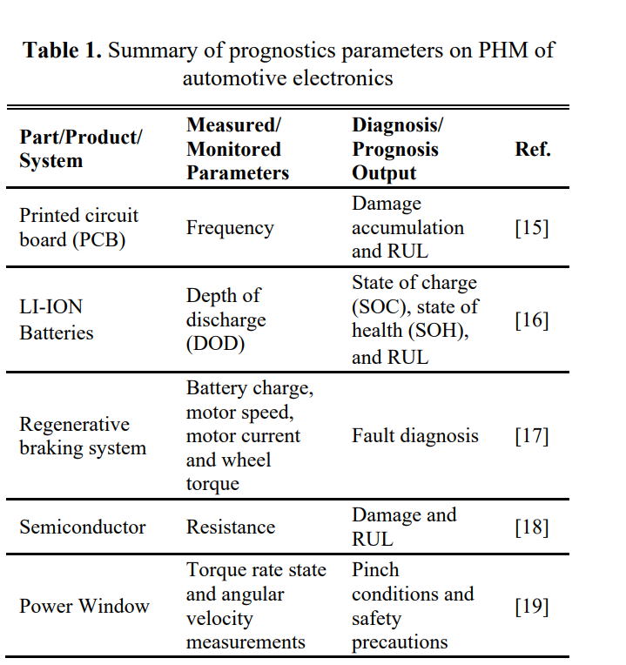

SAE levels with descriptions for autonomous driving [43]

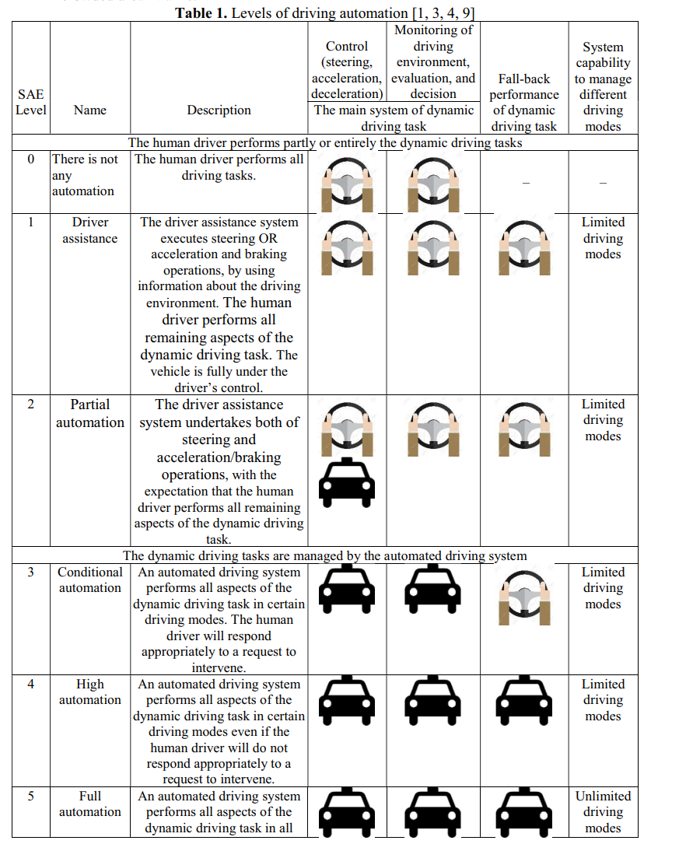

Percentages of types of faults in automotive from 2005-2015 [59]

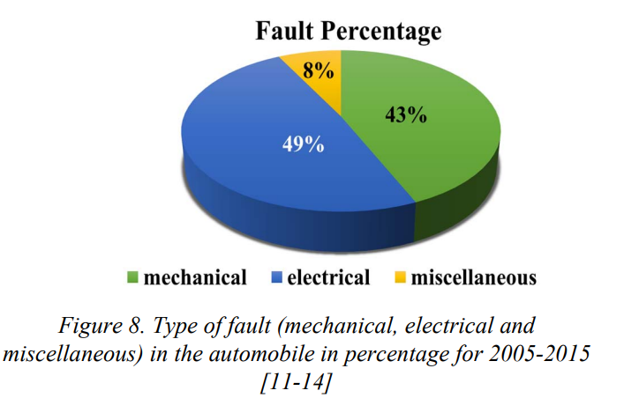

**B. Meeting Minutes**

|  |  |
| --- | --- |
| **Date and Time** | **Attendees** |
| October 11th 10:00 AM EST | Arafat Hasnain  Yidi Shen  Thomas Jones  Raghav Agarwal  Matthew Siebenhuhner |
| October 18th 10:00 AM EST | Arafat Hasnain  Yidi Shen  Thomas Jones  Raghav Agarwal  Matthew Siebenhuhner |
| October 25th 10:00 AM EST | Arafat Hasnain  Yidi Shen  Thomas Jones  Raghav Agarwal  Matthew Siebenhuhner |
| November 1st 10:00 AM EST | Arafat Hasnain  Yidi Shen  Thomas Jones  Raghav Agarwal  Matthew Siebenhuhner |
| November 8th 10:00 AM EST | Arafat Hasnain  Yidi Shen  Thomas Jones  Raghav Agarwal  Matthew Siebenhuhner |
| November 15th 10:00 AM EST | Arafat Hasnain  Yidi Shen  Thomas Jones  Raghav Agarwal  Matthew Siebenhuhner |
| November 22nd 10:00 AM EST | Arafat Hasnain  Yidi Shen  Thomas Jones  Raghav Agarwal  Matthew Siebenhuhner |
| December 6th 10:00 AM EST | Arafat Hasnain  Yidi Shen  Thomas Jones  Raghav Agarwal  Matthew Siebenhuhner |
| December 13th 10:00 AM EST | Arafat Hasnain  Yidi Shen  Thomas Jones  Raghav Agarwal  Matthew Siebenhuhner |

Communication started through email pretty much as soon as the initial project announcement was made. There was also a group chat which was used for constant communication throughout the week. This was the main mode of communication used to suggest changes and discuss the progress. We also created an online shared word doc which was used to co-ordinate all the report writing, All the group members were active in the group chat.

**C. Team Member Contributions**

Introduction

* Arafat Hasnain

Electrification

* Arafat Hasnain
* Matthew Siebenhuhner

Autonomous Driving

* Thomas Jones
* Yidi Shen

Connectivity

* Raghav Agarwal
* Yidi Shen

Conclusions

* All

I, Arafat Hasnain, focused on the general report introduction and the sections concerned with semiconductor dies, encapsulants, state of the art industry solutions, PCB integration, 3D packaging and advanced materials. For the presentation, I presented the project introduction, and in vehicle electrification – encapsulants, state of the industry solutions, future trends with PCB integration, 3D packaging and advanced materials.

I, Matthew Siebenhuhner, focused primarily on the sections concerned with die attach, die interconnects, substrates, heatsinks, transfer molded power modules, and press pack modules. For the presentation, I presented the general concepts of electrifications – dies, die attach, wire bonds, substrates, and heatsinks – as well as transfer molded power modules and press pack modules.

I, Thomas Jones, focused on the autonomous driving section of the report including SAE definition and timelines, LiDAR, camera, and software integration. For the presentation I covered the ADAS processors, the different systems used to include radar, LiDAR, and cameras, and software integration.

I, Yidi Shen, was involved in both sections of autonomous driving and connectivity, and focused on the packaging requirements, ADAS processors, radar packaging in autonomous driving section, and connectivity introduction, packaging requirements, 5G, processor packaging in connectivity section. For the presentation, I presented the introduction and packaging requirements for autonomous driving, and the introduction and hardware requirements for connectivity.

I, Raghav Agarwal focused mainly on the connectivity section of the report including hardware challenges and packaging challenges including advanced packaging techniques. For the presentation, I covered general packaging requirements for connectivity and solutions and strategies for different packaging challenges.